Susitna-Watana Hydroelectric Project

(FERC No. 14241)

Water Quality Modeling Study

Study Plan Section 5.6

Water Quality Model Development  
 Technical Memorandum

Prepared for

Alaska Energy Authority



Prepared by

URS Corporation/Tetra Tech, Inc.

June 2017

Table of Contents

1. Introduction 1

2. Background and Study Objectives 2

3. Study Area 3

4. Methods 3

4.1. Model Selection 3

4.2. Model Framework 4

4.3. Data Collection 6

4.3.1. Meteorological Data Collection 6

4.3.2. Baseline Water Quality Monitoring 7

4.3.3. Reach Geometry and Bathymetry 7

4.3.4. Sediment Loading 8

4.4. Model Development 9

4.4.1. River Model 10

4.4.2. Reservoir Model 11

4.4.3. FA-128 Slough 8A Model 11

4.4.4. Linkage 12

4.5. Mercury Modeling 13

5. Results 14

5.1. Calibration 14

5.1.1. Temperature Calibration 14

5.1.2. DO and Suspended Sediment Calibration 15

5.2. Validation 16

5.3. Model Sensitivity/Uncertainty 16

5.4. Results of Project Operation 18

6. Steps to Complete the Study 5.6 19

7. References Cited 20

8. Tables 22

9. Figures 27

List of Tables

Table 4.3-1. Inventory of Meteorological Station in the vicinity of the Susitna River 22

Table 4.3-2. Summary of sediment load relationships used for analysis 23

Table 4.3-3 Comparison of average annual sediment loads under pre-Project conditions 24

Table 4.3-4 Comparison of sediment concentration under pre-Project conditions 25

Table 4.4-1 Summary table of cell size statistics for river, reservoir and focus area model. 26

List of Figures

Figure 3-1. Susitna River study area and large-scale river segments. 27

Figure 3-2. Comparison of pre-Project (1974-1976) and post-Project (maximum load following scenario) river temperature along the Susitna River at the dam site, PRM 125, PRM 60 and PRM 29.9. 28

Figure 3-3. Comparison of pre-Project (1979-1981) and post-Project (maximum load following scenario) river temperature along the Susitna River at the dam site, PRM 125, PRM 60 and PRM 29.9. 29

Figure 3-4. Daily variation in temperature at PRM 29.9 for pre-Project (1974-1976) and post-Project maximum load following conditions. 30

Figure 3-5. Daily variation in temperature at PRM 29.9 for pre-Project (1979-1981) and post-Project maximum load following conditions. 31

Figure 4.4-1. Study 5.6 Riverine, Reservoir, and FA-128 (Slough 8A) EFDC model grid extents. 32

Figure 4.4-2. Study 5.6 FA-128 (Slough 8A) EFDC model grid extent detail. 33

Figure 5.1-1. River Model temperature calibration plots (PRM 152.7, 152.2, 142.3, 140). 34

Figure 5.1-2. River Model temperature calibration plots (PRM 88.3, 87.8, 59.9). 35

Figure 5.1-3 River Model DO calibration plot at PRM 29.9. 36

Figure 5.1-4 River Model DO calibration plot at PRM 33.6. 36

Figure 5.1-5 River Model DO calibration plot at PRM 59.9. 36

Figure 5.1-6 River Model DO calibration plot at PRM 87.8. 36

Figure 5.1-7 River Model DO calibration plot at PRM 107. 36

Figure 5.1-8 River Model DO calibration plot at PRM 124.2. 36

Figure 5.1-9 River Model DO calibration plot at PRM 142.3. 37

Figure 5.1-10 River Model DO calibration plot at PRM 152.7. 37

Figure 5.1-11 River Model DO calibration plot at PRM 174. 37

Figure 5.1-12 River Model sediment calibration plot at PRM 29.9. 37

Figure 5.1-13 River Model sediment calibration plot at PRM 32.5. 37

Figure 5.1-14 River Model sediment calibration plot at PRM 33.6. 37

Figure 5.1-15 River Model sediment calibration plot at PRM 45.1. 38

Figure 5.1-16 River Model sediment calibration plot at PRM 59.9. 38

Figure 5.1-17 River Model sediment calibration plot at PRM 87.8. 38

Figure 5.1-18 River Model sediment calibration plot at PRM 102.8. 38

Figure 5.1-19 River Model sediment calibration plot at PRM 107. 38

Figure 5.1-20 River Model sediment calibration plot at PRM 118.6. 38

Figure 5.1-21 River Model sediment calibration plot at PRM 124.2. 39

Figure 5.1-22 River Model sediment calibration plot at PRM 140.1. 39

Figure 5.1-23 River Model sediment calibration plot at PRM 142.2. 39

Figure 5.1-24 River Model sediment calibration plot at PRM 142.3. 39

Figure 5.1-25 River Model sediment calibration plot at PRM 152.3. 39

Figure 5.1-26 River Model sediment calibration plot at PRM 152.7. 39

Figure 5.1-27 River Model sediment calibration plot at PRM 174. 40

Figure 5.1-28 River Model sediment calibration plot at PRM 187.2. 40

Figure 5.4-1. 1974–1976 Simulation boundary conditions River Model temperature results. 41

Figure 5.4-2. 1976–1981 Simulation boundary conditions River Model temperature results. 42

Figure 5.4-3. Example temperature plots of FA-128 (Slough 8A) EFDC model results. 43

Figure 5.4-4. Upstream/Downstream FA-128 boundary comparisons for pre-and post-Project scenarios. 44

LIST OF ACRONYMS AND SCIENTIFIC LABELS

| Abbreviation | Definition |
| --- | --- |
| AEA | Alaska Energy Authority |
| DEM | Digital Elevation Model |
| DO | dissolved oxygen |
| EFDC | Environmental Fluid Dynamics Code |
| FA | Focus Area |
| FAA | Federal Aviation Administration |
| FERC | Federal Energy Regulatory Commission |
| ILP | Integrated Licensing Process |
| ISR | Initial Study Report |
| LiDAR | Light Detection and Ranging |
| NAVD88 | North American Vertical Datum of 1988 |
| NOAA | National Oceanic and Atmospheric Administration |
| POC | Proof of Concept |
| PRM | project river mile |
| Project | Susitna-Watana Hydroelectric Project |
| QAPP | Quality Assurance Project Plan |
| RSP | Revised Study Plan |
| RWIS | Road Weather Information System |
| SIR | Study Implementation Report |
| SCR | Study Completion Report |
| TSS | total suspended solids |
| USGS | United States Geological Survey |
| VOGG | Visual Orthogonal Grid Generator |

# Introduction

The Alaska Energy Authority (AEA) is preparing a License Application that will be submitted to the Federal Energy Regulatory Commission (FERC) for construction and operation of the Susitna-Watana Hydroelectric Project (Project). The Project is located on the Susitna River, an approximately 300-mile long river in the Southcentral Region of Alaska. The Project’s proposed dam site would be located at Project River Mile (PRM) 187.1 upstream of a steep, turbulent part of the river referred to as Devil’s Canyon. Project operations will cause seasonal, daily, and hourly changes in Susitna River flows that will differ from existing conditions (i.e., without Project). The potential alteration in flows will influence downstream resources and riverine processes, including fish and aquatic biota and their habitats, channel form and function including sediment transport, water quality, groundwater/surface water interactions, ice dynamics, and riparian and wildlife communities.

This Water Quality Modeling Study, Section 5.6 of the Revised Study Plan (RSP) approved by the FERC for the Susitna-Watana Hydroelectric Project, FERC Project No. 14241, focuses on predicting the potential impacts of the dam and its proposed operations on water quality through the development of a water quality model (AEA 2012). The goal of the Water Quality Modeling Study is to utilize the extensive information collected from the Baseline Water Quality Study (Section 5.5 of the RSP) to develop a model(s) to evaluate the potential impacts of the proposed Project and operations on various physical parameters within the Susitna River watershed.

On April 1, 2013, the RSP Section 5.6 was approved by FERC with modifications: Calibration of the Hydrodynamic Model Component of Environmental Fluid Dynamics Code (EFDC) – “We recommend that AEA incorporate water-surface elevations and flow velocities when calibrating the hydrodynamic model and that the hydrodynamic model be calibrated prior to the calibration of the water quality model component of the EFDC model.” AEA included FERC’s requested modification in the Final Study Plan

As required under FERC’s regulations for the Integrated Licensing Process (ILP), the Initial Study Report (ISR) describes AEA’s “overall progress in implementing the study plan and schedule and the data collected, including an explanation of any variance from the study plan and schedule.” (18 Code of Federal Regulation 5.15(c)(1)). The November 2015 Study Implementation Report (SIR) (Tetra Tech 2015b) demonstrated key developments of the study including the configuration and testing or the reservoir, riverine, and Focus Area 128 (FA-128) (Slough 8A) models through a proof of concept (POC) modeling.

This report describes AEA’s overall progress in implementing the Water Quality Modeling Study. Rather than a comprehensive reporting of all field work, data collection, and data analysis since the beginning of AEA’s study program, this report is intended to document the water quality model development, calibration, and initial results.

# Background and Study Objectives

Predicting the potential impacts of the dam and its proposed operations on water quality requires the development of a water quality model. In the 1980s, hydrologic and temperature modeling was conducted in the Susitna River basin to predict the effects of one or more dams on downstream temperatures and flows. The modeling suite used was H2OBAL/SNTEMP/DYRESM. The modeling suite addressed temperature and had some limited hydrodynamic representation, but it lacked the ability to predict vertical stratification or local effects. In addition, the modeling suite lacked a water quality modeling component.

The collective goal of the water quality studies is to assess the impacts of the proposed Project operations on water quality in the Susitna River basin with particular reference to state water quality standards. The objectives of the Water Quality Modeling Study are as follows:

* Implement (with input from licensing participants) an appropriate reservoir and river water temperature model for use with past and current monitoring data.
* Using the data developed as part of the Baseline Water Quality Study, model water quality conditions in the proposed Watana Reservoir, including (but not necessarily limited to) temperature, dissolved oxygen (DO), fine suspended sediment and turbidity, chlorophyll-*a*, nutrients, ice, and metals.
* Model water quality conditions in the Susitna River downstream of the proposed site of the Watana Dam, including (but not necessarily limited to) temperature, DO, fine suspended sediment and turbidity, chlorophyll-*a*, and nutrients. Ice processes effects are accounted for using output from the River 1D Ice Processes Model (in coordination with the Ice Processes Study).

Study 5.6 consists of the following components:

* Model selection (evaluation of several candidate models and selection of one that meets study objectives)
* Reservoir and river modeling (development, parameterization, configuration, and calibration of each model)
* Focus Area modeling (development, parameterization, configuration, and calibration of a model with enhanced spatial resolution)
* Consideration of modeling scale and resolution of output (determine the appropriate scale for evaluating post-Project water quality conditions)
* Modeling of operational scenarios (existing conditions and operational scenarios and distribution of results to other studies)

# Study Area

T­he study area initially began at PRM 19.9 and extended past the proposed dam site to PRM 235.2 (Figure 3-1). The downstream PRM was subsequently changed to PRM 29.9; the Project area upper boundary remained at PRM 235.2 (Tetra Tech 2014a).Water quality samples will be collected at the same locations where temperature data loggers were installed.

Water quality modeling was conducted from the proposed dam site at PRM 187.1 downstream to PRM 29.9. Modeling was conducted using operations scenario OS-1b that represented a most extreme load following condition (Study 8.5 ISR Part C, Section 7.41). Scenario OS-1b has lower flows and greater daily flow fluctuations during May and June compared to the intermediate load following scenario, ILF-1. Initial model results comparing existing conditions to operating scenario OS-1b indicated that DO concentrations tend to be near saturation in the Lower River and saturation conditions were expected to show no significant change between pre- and post-Project conditions at PRM 29.9. Modeling also indicated that water temperature at PRM 29.9 showed little or no change in temperature patterns over the year (Tetra Tech 2014a). Even under the most extreme operating scenario of OS-1b (Study 8.5 ISR Part C, Section 7.41), water temperature differences at PRM 29.9 were less than 1 °C and exhibited a random mode rather than consistently higher or lower differences between pre- and post-Project scenarios (Figures 3-2 through Figure 3-5). The maximum 1 °C temperature differences are based on instantaneous hourly values, with the 3-year average difference being less than 0.5 °C. The differences between pre-Project and post-Project temperatures on a specific day are typically similar to or less than the diurnal temperature variation of a given day. Figures 3-4 and 3-5 show correlation plots and regression results indicating on average, post-Project temperatures at PRM 29.9 exceed pre-Project temperatures by approximately one percent. It is important to recognize and acknowledge the significant influence of the Yentna River, which comprises about 40 percent of the average annual Susitna River discharge, on Susitna River temperature and other water quality variables below its confluence.

Since effects from Project operations on temperature were calculated to be minimal at PRM 29.9, temperature was expected to be unchanged by Project operations further downstream. The DO concentrations in the mainstem of the Susitna River tend to be near saturation, particularly in the lower 90 miles of the river (*Study 5.6, September 2014, Baseline Water Quality Study (Study 5.5) and Water Quality Modeling Study* *(Study 5.6), Water Quality and Lower River Modeling Technical Memorandum*, Section 5.2, Figure 6.2-5). DO saturation concentration is primarily a function of water temperature and saturation concentrations are not expected to change significantly in the Lower River post-Project. The observed saturation conditions are expected to show no significant change between pre- and post-Project conditions at PRM 29.9 (Tetra Tech 2014a).

# Methods

## Model Selection

For Study 5.6, AEA conducted an evaluation of each model against established key factors and selected EFDC as the 3-dimensional (3-D) reservoir water quality model, 2-dimensional (2-D) river water quality model, and 2-D river water quality model with enhanced resolution focus areas for this Project. Important considerations for model selection included prediction of vertical stratification in the reservoir with dam present, nutrient and algae representation, the ability to represent metals concentrations, integration between temperature and ice dynamics models, and capability of representing local effects. A full discussion of all the models is provided in Section 5.6 of the RSP.

EFDC is capable of simulating both river and reservoir environments. It is a multi-dimensional dynamic model that includes hydrodynamics, water temperature, water quality, and sediment transport modules and considers ice formation and break-up. Because EFDC was used for each modeling aspect, each separate model component is easily integrated. The 3-D reservoir model is used to predict water quality of dam releases, the 2-D river model to predict downstream changes in water quality and boundary conditions for focus areas, and the 2-D enhanced resolution model is used for focus areas.

EFDC was selected for the Project because of its ability to dynamically simulate an entire suite of water quality parameters, and is internally coupled with the hydrodynamic and temperature modeling processes over multiple years. EFDC was configured to simulate the impact of the proposed Project on temperature as well as DO, nutrients, algae, turbidity, total suspended solids (TSS), and other key water quality features both within the reservoir and for the downstream river. This avoids the complexity associated with transferring information among multiple models for Study 5.6 and increases the efficiency of model application.

## Model Framework

EFDC is a general purpose modeling package for simulating one- or multi-dimensional flow and transport and biogeochemical processes in surface water systems including rivers, lakes, estuaries, lakes, wetlands and coastal regions. It supports curvilinear and orthogonal grids on the horizontal plane to best-fit shoreline and sigma coordinate in the vertical direction, which divide the water columns into user-defined layers (Hamrick 1996). EFDC is unique among current surface water modeling systems in that it incorporates fully three-dimensional hydrodynamics, temperature, sediment and eutrophication simulation capabilities in a single, internally linked framework.

The EFDC model’s structure has four major modules: (1) hydrodynamic, (2) water quality/ eutrophication, (3) sediment transport and (4) toxics.

The physics of the EFDC model and many aspects of the computational scheme are equivalent to the widely used Blumberg-Mellor model (Blumberg and Mellor 1987) and the U.S. Army Corps of Engineers CH3D or Chesapeake Bay model (Johnson et al. 1993). The EFDC model solves the vertically hydrostatic, free-surface, turbulent-averaged equations of motions for a variable density fluid. Dynamically coupled transport equations for turbulent kinetic energy, turbulent length scale, salinity, and temperature are also solved. The two turbulence parameter transport equations implement the Mellor-Yamada level 2.5 turbulence closure scheme (Mellor and Yamada 1982; Galperin et al. 1988). The EFDC model uses a stretched or sigma vertical coordinate and cartesian or curvilinear, orthogonal horizontal coordinates.

The numerical scheme used to solve the equations of motion uses second-order accurate spatial finite differencing on a staggered or C grid. The model’s time integration uses a second-order accurate three time-level, finite difference scheme with an internal-external mode splitting procedure to separate the internal shear or baroclinic mode from the external free surface gravity wave or barotropic mode. The external mode solution is semi- implicit, and simultaneously computes the two-dimensional surface elevation field by a preconditioned conjugate gradient procedure. The external solution is completed by the calculation of the depth averaged barotropic velocities using the new surface elevation field. The model’s semi-implicit external solution allows large time steps that are constrained only by the stability criteria of the explicit central difference or high-order upwind advection scheme (Smolarkiewicz and Margolin 1993) used for the nonlinear accelerations. Horizontal boundary conditions for the external mode solution include options for simultaneously specifying the surface elevation only, the characteristic of an incoming wave (Bennett and McIntosh 1982), free radiation of an outgoing wave (Bennett 1976; Blumberg and Kantha 1985), or the normal volumetric flux on arbitrary portions of the boundary. The EFDC model's internal momentum equation solution, at the same time step as the external, is implicit with respect to vertical diffusion. The internal solution of the momentum equations is in terms of the vertical profile of shear stress and velocity shear, which results in the simplest and most accurate form of the baroclinic pressure gradients and eliminates the over-determined character of alternate internal mode formulations. Time splitting inherent in the three time- level scheme is controlled by periodic insertion of a second-order accurate two-time level trapezoidal step. The EFDC model is also readily configured as a two-dimensional in either the horizontal or vertical planes, and as a one-dimensional model.

The EFDC model implements a second-order accurate in space and time, mass conservation fractional-step solution scheme for the Eulerian transport equations for salinity, temperature, suspended sediment, water quality constituents, and toxic contaminants. The transport equations are temporally integrated at the same time step or twice the time step of the momentum equation solution (Smolarkiewicz and Margolin 1993). The advective step of the transport solution uses either the central difference scheme used in the Blumberg-Mellor model or a hierarchy of positive definite upwind difference schemes. The highest accuracy upwind scheme, second order accurate in space and time, is based on a flux-corrected transport version of Smolarkiewicz’s multidimensional positive definite advection transport algorithm (Smolarkiewicz and Clark 1986; Smolarkiewicz and Grabowski 1990), which is monotonic and minimizes numerical diffusion. The horizontal diffusion step, if required, is explicit in time, while the vertical diffusion step is implicit. Horizontal boundary conditions include time variable material inflow concentrations, upwinded outflow, and a damping relaxation specification of climatological boundary concentration. For the temperature transport equation, the National Oceanographic and Atmospheric Administration (NOAA) Geophysical Fluid Dynamics Laboratory’s atmospheric heat exchange model (Rosati and Miyakoda 1988) is implemented. The EFDC model is capable of simulating an infinite number of sediment size classes and multiple sediment size classes will be used to simulate the settling and resuspension of sediment. The particle size distribution from existing monitoring data will be evaluated and the final number of sediment size classifications will be determined during model calibration.

The EFDC model has been extensively tested, documented, and applied to environmental studies world-wide by universities, governmental agencies, and environmental consulting firms. In addition to hydrodynamic, salinity and temperature transport simulation capabilities, EFDC is capable of simulating cohesive and non-cohesive sediment transport, near-field and far-field discharge dilution from multiple sources, eutrophication processes, the transport and fate of toxic contaminants in the water and sediment phases, and the transport and fate of various life stages of finfish and shellfish.

The water quality module in EFDC is functionally equivalent to the CE-QUAL-ICM model (Cerco and Cole 1993). The water quality/eutrophication module simulates the spatial and temporal distributions of 22 water quality parameters including: DO; phytoplankton; various components of carbon, nitrogen, phosphorus and silica cycles; and fecal coliform bacteria. Not all variables need to be activated to simulate eutrophication. In addition to these variables, water temperature is one of the major governing factor for the biochemical reactions, while TSS can absorb phosphate and can block solar radiation, which will affect the growth of phytoplankton. Water temperature and TSS are provided by the hydrodynamic module and sediment transport module. The eutrophication models can be executed simultaneously with the hydrodynamic module of EFDC. EFDC accepts an arbitrary number of point and nonpoint source loadings and atmospheric and groundwater loadings.

Strengths of EFDC include:

* A history of being used to support modeling studies throughout the country.
* A history of being one of the most accurate methods of representing physical, chemical, and biological processes, particularly for the parameters of interest for this modeling study.
* The ability to simulate hydrodynamics and be used to evaluate changes in vertical mixing due to proposed dam operation scenarios.
* The ability to predict time-variable nutrient, algae, and DO levels; thus inherently evaluates critical conditions.
* The added benefit of predictive sediment diagenesis and representation of lateral variability.

## Data Collection

The river model requires multiple types of data from multiple sources, including other studies. For instance, water quality data was obtained from Study 5.5. Other sources of data included meteorological, LiDAR (light detection and ranging) remote sensing, and channel geometry.

### Meteorological Data Collection

Weather conditions are major driving forces for water temperature and circulation. Important weather data for EFDC are air temperature, relative humidity, precipitation, evaporation, solar radiation and wind. The meteorological data are specified in two separate files for the EFDC model (*aser.inp* and *wser.inp*). The *aser.inp* file is used to specify the atmospheric pressure, air temperature, relative humidity, precipitation, evaporation, solar radiation and cloud cover. The *wser.inp* file is used to specify the wind speed and direction.

Meteorological data were identified from various agency sources for six stations in the vicinity of the Susitna River. Three of the meteorological stations (EMS-1, EMS-2, and EMS-3) were installed during September 2012 specifically to be used for modeling the proposed Susitna Reservoir (Susitna River at Indian River, Susitna River at Watana Dam, Susitna River above Oshetna). Data from the data stations established between PRM 142.2 and PRM 235.2 (EMS-1, EMS-2, and EMS-3), as well from the three existing data stations located between Willow Creek and the Talkeetna Airport were continually downloaded. Additional information on the meteorological data collection effort is documented in the Study 5.5 Study Completion Report (SCR).

Fifteen-minute data were collected from these three stations until October 2013. In addition, data were also acquired from three additional existing meteorological stations – two hourly stations from NOAA’s National Climate Data Center (Willow Airport WBAN 26560; Talkeetna Airport: FAA/NOAA Station WBAN 26528) and one from Alaska’s Road Weather Information System (RWIS) (Talkeetna RWIS: Parks Highway @ Talkeetna Rd. MP 98.7), which provided sub-hourly data for the various required parameters.

Available data for the period from 2010 onwards were downloaded and used in creating the meteorological inputfiles for the EFDC model. All data were preprocessed to fill in the missing data. When data was missing for short periods (few hours to couple of days) it was filled using available data from the previous hour. Data were also plotted to evaluate if there were any extreme data points that were not flagged. Time series data were prepared in the required EFDC meteorological data file formats after applying appropriate unit conversions.

### Baseline Water Quality Monitoring

All baseline water quality samples collected in 2013 as part of Study 5.5 have undergone quality assurance/quality checks per the quality assurance project plan (QAPP). Baseline water quality monitoring samples were collected each month from June 2014 through September 2014 at five sites during winter 2014 and 17 sites from PRM 29.9 to PRM 235.2. In-situ field measurements were collected at each location using a Hydrolab® datasonde (MS5). A single grab sample was collected monthly at each location and analyzed for all total metals (except calcium and magnesium) and dissolved aluminum, total phosphorus, total Kjeldahl nitrogen, and nitrate+nitrite-nitrogen. Additional information on the water temperature data collection effort is documented in the Study 5.5 SCR.

### Reach Geometry and Bathymetry

Within the Lower and Middle Susitna River Segments, channel geometry was surveyed at selected cross sections during (1) the 2012 summer field season, (2) late September/October 2012 post-flood event, and/or (3) the 2013 field season. The surveyed extent at each section was generally between the banks of the main channel(s). The overbank geometry was derived from the Matanuska-Susitna LiDAR mapping collected in 2011 and indexed to the NAVD88 (feet) in 2013. LiDAR data was collected at a 1-meter resolution. The 1-meter digital elevation map (DEM) was merged and clipped to the proposed shoreline for processing. The LiDAR data covered the entire proposed shoreline except for a small portion of the shallow outer portion of the southern arm, where Kosina Creek feeds into the proposed reservoir, and a small area near the outer extents of the shallow northern arm where Jay Creek feeds into the proposed reservoir. Since the LiDAR mapping does not include below-water geometry, the field-surveyed geometry was merged into the LiDAR geometry for the riverine portions of the model. Each surveyed point was projected onto the transect line and a horizontal station value was determined. The model currently uses the 2011 indexed Mat-Su Borough LiDAR for terrestrial elevations. Reservoir volume and surface area statistics are provided below.

*Volumes estimated below Normal Pool 2,050 ft*

* DEM (1 m) using ArcGIS 3D analyst (5.17 million ac-ft)
* EFDC model Bathymetry
  + Interpolated depths (5.26 million ac-ft)
  + Adjusted depths (5.25 million ac-ft)
* December 2012 RSP Section 1.3 (5.2 million ac-ft)
* Engineering Feasibility Report (MWH 2014) Table 1.8-1 (5.17 million ac-ft)

*Surface Area estimated below Normal Pool 2,050 ft*

* DEM (1 m) using ArcGIS 3D analyst (2D area = 23,133 acre)
* EFDC model Bathymetry (23,926 ac)
* December 2012 RSP Section 1.3 (23,546 ac)
* Engineering Feasibility Report (MWH 2014) Table 1.8-1 (23,500 acres)

The EFDC hydrodynamic model currently contains bathymetry from 88 cross sections surveyed in 2012, with 75 of the cross sections in the Middle River and the remaining 13 in the Lower River. Cross sections were surveyed between PRM 80 and 188 (RM 75 and RM 184) (excluding the 12-mile length of river in the Devil’s Canyon area) with an average spacing of just over 1 mile. The minimum and maximum spacing between the cross-sections was 0.1 and 3 miles, respectively. There are 29 cross sections in the Middle River and 51 cross sections in the Lower River from the 2013 surveys that have also been used in the model development.

### Sediment Loading

Sediment loadings from the upstream Susitna River and the tributaries were needed to configure the sediment transport model for the river. The monitoring data were not sufficient enough to directly derive the sediment loadings. Therefore, sediment loading curves were used to derive the boundary loading conditions. Sediment loading curves (sediment load versus water discharge) were developed at: Denali, Cantwell (Vee Canyon), Gold Creek, Sunshine, and Susitna Station, and on the three largest tributaries, the Chulitna, Talkeetna, and Yentna Rivers. The relationships were developed for three sizes of sediment, wash load (silts and clay), sand load and gravel load since the ability of the river to transport sediment and its response to the sediment being supplied varies greatly with the size of the sediment. Table 4.3-2 presents the regression equations for load versus discharge at Susitna River at Gold Creek, Sunshine, and Susitna Station, as well as on the Chulitna, Talkeetna, and Yentna rivers. Full details of the relationship development are provided in the *2014 Update of Sediment-Transport Relationships and a Revised Sediment Balance for the Middle and Lower Susitna River Segments Technical Memorandum* (Tetra Tech, Inc. 2014b). The relationships were applied to the long term hydrologic conditions represented by existing (pre-Project) conditions (Tetra Tech 2014b). The data collected in 2012 and 2013 are very similar to previous data collected by the United States Geological Survey (USGS). Since silt and clay are the main components in the suspended sediment, the model only considers silt and clay in this study.

Three main stem gages and three primary tributary gages locations downstream of the Project site PRM 187.1 (Figure 3-1) were used to characterize the sediment-transport regime under the 61-year hydrology record for each portion of the reach.

All ungaged tributary loads were assumed to be at negligible levels for the Lower River (Tetra Tech 2014b). In many cases these tributaries cross terraces before feeding into side channels. There are also no significant fan deposits at these tributaries. Although these estimates are low, the amounts of sediment delivered from non-major tributaries is insignificant compared to the Susitna River transport. Table 4.3-3 summarizes the small amount of data available on the two representative tributaries, labeled “ungaged tributaries.” Sediment transport models are being developed to estimate tributary sediment supply to the Lower River, but field observations indicate that these loads are minimal for all but the major tributaries. These results do bring into question some of the values in Table 4.3-3, primarily when the supply above Sunshine (or Susitna Station) is less than the amount computed at Sunshine (or Susitna Station). Although these differences could be attributed to tributary inputs, other factors could be contributing to these differences. The factors include bank erosion into terraces, landslides that briefly produce large amounts of sediment, or uncertainties in computing the loads. The differences are less than 10 percent for total load, which for sediment load estimates is well within the acceptable level of uncertainty.

To demonstrate the differences between the glacially fed source areas and minor tributaries, Table 4.3-4 shows mean annual sediment concentrations in (parts per million) ppm by weight. At low concentrations these ppm values are essentially the same as concentration in mg/L. In Table 4.3-4, silt/clay loads along the Susitna River and its major tributaries range from 200 to 600 ppm, sand loads range from 150 to 500 ppm, and gravel from 3 to 50 ppm. This compares to less than 10 ppm for silt/clay and sand for the measurements at Indian River and Portage Creek and generally between 10 and 20 ppm for gravel. In terms of sediment concentration (weight of sediment divided by the weight of water-sediment mixture), the Middle River tributary flows may contain only 0.01 times the concentration of silt/clay, 0.04 times the concentration of sand, but as much as 10 times the gravel than mainstem Middle River flows. The mean sediment concentration of the ungaged Middle and Lower River tributaries was approximately 2 ppm. Pre-Project concentration for the middle river tributary was considered to be 3 ppm, while the lower river tributary condition was zero ppm, as non-glacial fed streams below the dam are essentially clear. For the purpose of this modeling effort, 2 ppm was used for all tributaries with low sediment concentrations.

## Model Development

Model development involves generating the model grid, processing and specifying the boundary conditions, configuring the initial conditions, and calibrating the model. Calibration is discussed in Section 5.1, the remainder are discussed throughout this section. The reservoir, riverine, and FA-128 (Slough 8A) models have been configured and tested, as shown in the POC modeling. The riverine POC model indicated that the model is stable and had an acceptable run-time performance. The reservoir POC model demonstrated that the vertical resolution captures thermal stratification and mixing processes in the reservoir model. The extents of these three models are shown in Figure 4.4-1.

To configure the EFDC model, the riverine and reservoir portions of the system were divided into smaller segments, both horizontally and vertically. This process is called grid generation. The grid was generated using shoreline and bathymetric data with two programs: Visual Orthogonal Grid Generator (VOGG) and GridEFDC. VOGG was used to generate grids in areas with simple shorelines. GridEFDC was used to generate grids with complex shorelines and to merge different pieces of grids. VOGG and GridEFDC generated different pieces of the grids to account for variable shoreline characteristics throughout the lake. VOGG is a tool that allows visual adjustment of the curvilinear grid (Tetra Tech 2002). GridEFDC requires user inputs of boundary points when generating the grid (Hamrick 1996). The different grid pieces were then manually merged. The river model grid was generated using GridEFDC and the grid for FA-128 (Slough 8A) was generated using VOGG. Grid specifics for each model is discussed in their representative subsections below. There were no hydraulic structures explicitly included in the EFDC except for the outfall from the dam. There are only two bridges crossing the river in the entire study area (Railroad at Gold Creek and Parks Highway at Sunshine) and the decks of both of these structures are well above the 100-year water surface elevation.

Bathymetry changes resulting from reservoir construction and operation are not included because these sediments have very little interaction with the channel bed. The Fluvial Geomorphology Modeling Study (Study 6.6) couples the transport of sand and coarser sediments with hydrodynamics and does include bathymetry changes related to reservoir operation.

### River Model

The river model was developed for model calibration as well as for pre-Project and post-Project simulations. The river model was initially configured spatially between PRM 59.9 and PRM 187.2 with approximately 1,000 horizontal grid cells. Channel bathymetry is based on 88 cross sections surveyed in 2012. This configuration is being extended downstream to PRM 29.9 using additional cross sections surveyed during 2013 and higher resolution surveys in a number of Focus Areas. Statistics on the cell size are presented in Table 4.4-1.

Although a model grid has not been developed for a braided channel in the Lower River, EFDC has been used to represent FA-128 (Slough 8A), which is a braided stream network in the Middle River (Section 4.4.3). The bathymetry data from this section identify a main channel and numerous side channels and sloughs. The bathymetry data were applied in grid development and allow for the representation of channels as well as shallow or dry depositional areas and island features. These features can be similarly represented in any section of the Susitna River. The April 2014 POC meeting included a presentation on EFDC POC model runs using a higher resolution grid for FA-128 (Slough 8A), which showed that EFDC can be used in a braided channel environment (POC Riverine Water Quality Modeling FA-128 April 15-17, 2014 presentation). In addition, EFDC has been successfully used for braided networks to model hydrodynamic and sediment transport in the Kalamazoo River (LimnoTech 2015), Sheep River water quality model (Tetra Tech 2014c), and to study PCB contamination in the Housatonic River (Weston Solutions 2006).

The flow boundary conditions were derived from observed data. For pre-Project conditions, the upstream river temperature boundary was based on a three-year synthesized temperature record, which correlated recent observed temperatures with time of year and river flow. Flow and water temperature from the reservoir model provided upstream boundary conditions for the post-Project river model. Water temperature time series were assigned to each flow time series in the model. The water temperature data were a composite of the observed 2012/2013 meteorological data patched with estimated parameters using regression and average hourly values observed at the site. DO and suspended sediment concentrations were also configured for model calibration. Since the Susitna River does not have high levels of benthic algae, the DO in the river is mainly impacted by water temperature. The upstream and tributary DO boundary conditions were assigned to the saturation level using the water temperature associated with the tributary flow. For suspended sediment concentrations, silt and clay were considered and configured as one type of fine sediment in the EFDC model. The upstream and tributary sediment concentrations were derived from the sediment loading curves that are discussed in Section 4.3.4.

The water column initial conditions for the riverine section have insignificant impacts to model results because of the short retention time (i.e., outside conditions, such as upstream flow or runoff, quickly change the conditions in the river); therefore, it can be set to a reasonable value estimated using monitored data. An initial bed condition was provided and adjusted during model calibration for sediment transport.

Downstream of the proposed dam location, the same model platform used for the reservoir model was implemented for the river model, maintaining consistency of state variables and process representations. The (2-D) River Water Quality Model is capable of representing conditions in both the pre-Project absence and post-Project presence of the dam.

### Reservoir Model

The reservoir model represents the river from the proposed dam location to the upstream extent of inundation. Its purpose is to represent the proposed reservoir condition when the dam is in place. The reservoir representation was developed based on the local bathymetry and dimensions of the proposed dam. The reservoir model was developed in 3-D to represent the spatial variability in hydrodynamics and water quality in longitudinal, vertical, and lateral directions. The reservoir model was spatially configured with approximately 1,400 horizontal grid cells and 20 vertical layers. Vertical resolution with 20 layers ranges from an 8.2-foot layer thickness near the surface to an 82-foot thickness near the bottom of the deepest area. The number of layers varies to account for topographic variations. The reservoir hydrodynamic model was tested using the 1984 historical inflow and a corresponding load following outflow. The model successfully simulated the one year period which had an approximately 150-foot variation in pool level. Temperature simulation for ice-free conditions indicated that the 20 layer configuration adequately represents vertical stratification. The topographic layer used to configure the model is based on the Matanuska-Susitna Lidar DEM. Statistics on the cell size are presented in Table 4.4-1.

Data used for the riverine model boundary conditions were used to configure the flow and temperature boundary conditions for the reservoir. The corresponding temperature was set using available data from adjacent tributaries for lateral boundary conditions when temperature data was not available. These are used in the initial model runs along with model calibration and for future model runs. The end state was used as the initial condition. Due to the deep nature of the reservoir, the sediment bed movement will not be simulated as an active component; therefore, there was not a need for a bed initial condition. Sediment loadings to the reservoir will be derived from the sediment rating curves (sediment discharge vs. water discharge) developed from data collected by the USGS in Study 6.5 (2012–2014) and collected by the USGS in the 1980s in the Geomorphology Study (6.5).

### FA-128 Slough 8A Model

The EFDC Model has been locally enhanced with finer spatial resolution to more accurately simulate water quality processes and predict conditions in the riverine focus areas, specifically FA-128 (Slough 8A). Currently, a refined grid has only been developed for Focus Area FA-128 (Slough 8A), as shown in Figure 4.4-2, though higher resolution bathymetric data are available for Focus Areas FA-104 (Whiskers Slough), FA-113 (Oxbow 1), and FA-115 (Slough 6A). The EFDC riverine model has 2-D elements in each of the Focus Areas representing the important lateral habitats of interest. The Focus Area models will be used for predicting conditions in sloughs and selected braided areas of the mainstem Susitna River. The FA-128 (Slough 8A) model, from PRM 129.7 to PRM 128.1, was configured separately from the full river model. FA-128 (Sough 8A) has one layer and 8,372 horizontal cells. Statistics on the cell size are presented in Table 4.4-1.

### Linkage

Different models developed in this study are linked together to simulate water temperature and quality at different locations along the river. For the pre-Project conditions, the river model and the FA-128 model conduct the simulation. Observational data provided the upstream boundary conditions for the pre-Project version of the river model. Flow and water temperature output from the riverine model are directly input as the boundary conditions and model inputs in the FA-128 (Slough 8A)-specific riverine model.

For the post-Project conditions, the reservoir model provides potential changes of conditions for the downstream river model. Flow and temperature data from the 3-D reservoir water quality model are directly input into the downstream post-Project version of the 2-D riverine model. The output of the riverine model is used to evaluate the conditions at downstream locations after the dam construction. As with the pre-Project conditions, flow and water temperature output from the riverine model are directly input as the boundary conditions and model inputs in the FA-128 (Slough 8A)-specific riverine model. This will enable downstream evaluation of potential impacts of the proposed Project on hydrodynamic, temperature, and water quality conditions.

The Ice Study (Study 7.6) will support water quality model development with information about timing and conditions for ice formation and ice break-up (RSP Section 5.6.7). Ice dynamics evaluated in the Ice Processes Study will be used to inform the water quality model. Ice formation and break-up will have a profound impact on hydrodynamics and water quality conditions in the reservoir and riverine sections of the basin. Ice cover affects transfer of oxygen to and from the atmosphere and this directly affects the DO concentration at points along the water column. The output from the Ice Processes Study will provide boundary conditions for the water quality model. The 1-D ice model provides ice cover information, which EFDC is able to read after processing the model results. The 1-D ice model also provides inflow and water temperature boundary conditions to the FA-128 (Slough 8A) model in EFDC. The EFDC model results are then provided to the fish habitat model as input.

Output from the water quality EFDC models will be used directly in other studies (e.g., ICE Study 7.6, River Productivity [RIVPRO] Study 9.8, and IFS Study 8.5). Currently, the water temperature output from the FA-128 (Slough 8A) model is being used as input to the fish habitat model as part of the IFS Study 8.5 analysis. The riverine EFDC model will provide surface water conditions from different locations as boundary conditions for the groundwater model. This process is still in development. The riverine EFDC will also be linked to the ice models.

The TSS results from the EFDC model will be converted to turbidity for input to IFS Study 8.5 analyses and RIVPRO Study 9.8. The correlations developed from the 2013 and 2014 data collected by the WQ Study 5.5 between TSS and turbidity are quite strong and will allow accurate predictions of turbidity over a large range of suspended solid concentrations. Separate regression models were constructed for turbidity versus TSS for each of the river segments: Lower River, Middle River, and Upper River.

## Mercury Modeling

Mercury modeling will occur after calibration of the nutrient cycling model. The incorporation of the mercury into EFDC model will be implemented as described in Section 5.6 of the RSP (AEA 2012). Before mercury can be included in the model, the hydrology and water quality calibration need to be complete. Mercury will be modeled in both the EFDC riverine and reservoir water quality models. In the case of the riverine EFDC model, mercury will be modeled from the reservoir outlet downstream to PRM 29.9 (Susitna Station).

Modeling of mercury concentrations in dissolved and in methylated form will be done by updating the 3-D reservoir water quality model to simulate three sorptive toxic variables representing mercury states. As stated in Section 4.2 of the Study 5.6 ISR Part A, algorithms have been successfully used with the 3-D reservoir water quality model in other watersheds and will be modified to account for potential sources of mercury as the reservoir is filled (e.g., soils, vegetation, air deposition). A suggested approach for estimating toxicity mixtures would be to develop a weight of evidence algorithm that produces a weighting factor for re-calculating the potential chronic and acute toxic effects of a mixture (Mumtaz et al. 1998). While the EFDC riverine mercury model can be calibrated, the mercury reservoir model cannot be calibrated; however, a sensitivity simulation will be conducted to span the range of realistic parameters. The primary reaction parameters—based on literature values—in the mercury-cycling model include:

* Methylation and demethylation rates
* Oxidation and reduction rates
* Volatilization rate and equilibrium concentration
* Photoreduction rate
* Partition coefficient

# Results

The models have been tested with potential Project flow scenarios to demonstrate stability and acceptable run-time performance in the April 2014 POC model runs. After the POC modeling, the river model was calibrated using temperature data from 2012 and 2013, as 2014 temperature data was not available. The calibration of the riverine model is described below. The model was only calibrated for the river, not specifically for FA-128 (Slough 8A). The FA-128 (Slough 8A) model uses the calibrated riverine model as an upstream boundary condition and also uses the model parameters that were calibrated in the riverine model.

## Calibration

Calibration refers to the process of comparing the model output against the observed data and iteratively adjusting appropriate parameters within reasonable ranges to improve agreement. The model has been calibrated for temperature, DO, and suspended sediment.

For calibration, a visual inspection is the primary approach as it can capture temporal and spatial trends. Time series and vertical profiles—when data are available—are used for visual inspections. Statistics can provide a secondary measurement to evaluate the model performance as well as information on the magnitudes of model errors and are used as guidelines to supplement the visual evaluation of model data plots for model calibration (Dynamic Solutions 2013). However, when data samples are limited, the statistics should be interpreted carefully. It must be noted that statistical analyses are only meaningful when there is enough data to make meaningful conclusions and need to be carefully interpreted when there is limited data. Statistics can be misleading when there is a slight time shift between the model results and data. During a time shift, the model is unable to match the exact timing of observed data (even by as little as an hour), so calculating error statistics would not be useful and would not tell the full story that the model is predicting parameter fluctuations and ranges, because the timing is slightly off. The model’s capability to mimic the general trend/pattern is more informative than error statistics. In addition, statistics are of limited use in discerning spatial and temporal trends along with responses to the external driving forces. These elements are important in water quality modeling and are evaluated through visual inspection of time series plots.

### Temperature Calibration

Typical calibration parameters for a riverine hydrodynamic model include temperature, flow velocity, and water surface elevation. Of these, only temperature data were available. Continuous temperature data for 2012–2013 were available for calibration (Study 5.5). The high-frequency temperature monitoring data used for calibration was collected at seven stations (PRM 152.7, PRM 152.2, PRM 142.3, PRM 140, PRM 88.3, PRM 87.8, and PRM 59.9). The data are available for different periods between July 2012 and September 2013.

During the calibration process, bottom roughness height, solar radiation adjustment factor, and air-water heat transfer coefficients were varied within a reasonable range. The performance of the model showed only negligible sensitivity to those parameters, and the temperature boundary conditions from the major tributaries contribute more significant impact. Therefore, all the parameters were restored to the default values, which still allows a good match between the simulated and observed temperature. The cause of the insensitivity of river water temperature to those parameters might be due to the fast moving character and high volume of the river, which would be expected to be more sensitive to tributary flows and temperature than to other external factors that would need sufficient exposure time to impose an effect. In subsequent work, a more formal sensitivity analysis will be conducted to evaluate how downstream temperature/water quality would respond to the variability in temperature/flow/water quality at the dam due to different operations.

The results of the model calibration versus the observed temperature data are presented in Figures 5.1-1 and 5.1-2. The plots present the modeled and observed temperature data starting with July 18, 2012 and running through October 2013. Figures 5.1-1 and 5.1-2 show the spatial representation of model performance by comparing the model results at multiple locations stretching along the length of the river, which show spatial variability of the model. The model results predicted temperature conditions acknowledging year-to-year variability as reflected in the period of record used to initially calibrate the module.

In general, the model is adequately calibrated for temperature. Figures 5.1-1 and 5.1-2 indicate the riverine model predicts the temperature well. The EFDC results show that the model performs sufficiently well in reproducing observed spatial and temporal variabilities in the river, suggesting that the data are adequate in evaluating whether the model correctly represents the underlying dynamics/physics and trend of observed temperature data and will be able to be used to predict potential impacts of the proposed Project and operations. On an annual basis, the data show that 2013 had higher water temperatures at all stations, and the model was able to predict that pattern. The model reproduces short-term magnitude and variability of water temperature as well. Even though data were only available at limited locations, the model is capable of generally reproducing observed conditions at these locations and it shows that the model is correctly representing the underlying dynamics/physics.

Slight differences in model results from observed data can be attributed to uncertainty from the model boundary conditions, as well as in the observed data. In addition, the observed data might have specific local conditions that deviate from the general pattern. For example, the observed temperature at PRM 88.3 is low and below 12 degrees Celsius (°C), but at PRM 87.8 (0.5 miles downstream), the observed temperature becomes significantly higher (almost 15 °C). While the model is able to reproduce the temperature at PRM 88.3 well, it cannot reproduce the higher temperatures at PRM 87.8 during the same period. PRM 87.8 is likely under the influence of local conditions or is not representative (e.g., the location of the Talkeetna Wastewater Treatment Facility outfall). Similarly, the high temperature at PRM 59.9 might be partly explained by local conditions given that with the flow rate and water volume during the period, the solar radiation would not have the ability to increase water temperature to that degree from the previous upstream observations.

### DO and Suspended Sediment Calibration

DO and suspended sediment were also calibrated. DO data were available for calibration at nine stations (PRM 174, PRM 152.7, PRM 152.2, PRM 142.3, PRM 124.2, PRM107, PRM 87.8, PRM 59.9, PRM 33.6, and PRM 29.9). The governing mechanism is the reaeration from air to water since DO is primarily impacted by water temperature when the river has low levels of algae. The reaeration was adjusted to 1 per day during model calibration. The DO calibration results and the observed DO data are presented in Figure 5.1-3 to 5.1-11. In general, the calibrated DO showed agreement with the observed data. The June 2013 DO data at PRM 124.2, PRM107, PRM 87.8, PRM 59.9, PRM 33.6, and PRM 29.9 were significantly higher than the DO saturation level, which was calculated using the modeled water temperature. Such differences are related to water temperature simulation as well as the boundary condition. Any over-predicting of water temperature results in under-predicting of DO. Due to the limitation of DO data, it is not possible to create DO loading boundary conditions on an hourly basis. Instead, DO saturation levels were used. Supersaturation levels of DO from the tributaries are not represented in the current model.

Suspended sediment data were available for model calibration at 17 stations (PRM 187.2, PRM 174, PRM 152.7, PRM 152.3, PRM 142.3, PRM 142.2, PRM 140.1, PRM 124.2, PRM 118.6, PRM107, PRM 102.8, PRM 87.8, PRM 59.9, PRM 45.1, PRM 33.6, PRM 32.5, and PRM 29.9 ). The main calibration parameters include the settling velocity and critical shear stresses for deposition and resuspension. The modeled suspended sediment concentrations do not change significantly with varying settling velocities and critical shear stresses. The suspended sediment concentrations in the river were mainly governed by the sediment loading. The reason could be that the high flow in the river does not allow suspended sediment to accumulate on the channel bottom after deposition. Instead, the suspended sediment might quickly re-enter the water column and are transported downstream.

The sediment model was run iteratively and model calibration results were compared with the observed data (Figure 5.1-12 to 5.1-28). Generally, the calibrated sediment concentrations agreed well with the observed data, especially in the lower portion of the river. The modeled suspended sediment is mainly impacted by the upstream Susitna River above the major tributary inputs (Chulitna River near Talkeetna, Talkeetna River near Talkeetna, and Yentna River near Susitna Station), which contribute significant amount of suspended sediments. However, no data were available above PRM 187.2, which is the upstream boundary location for the river model. The suspended sediment concentrations from the upstream boundary location were estimated using the sediment loading curve that was developed for Susitna River at Gold Creek. This introduced uncertainties in the model and caused the difference between modeled sediment and observed data. The modeled sediment and observed data agree well for the river portions below the Chulitna River from PRM 118.6 to PRM 59.9. The observed data showed a sudden decrease in sediment to a very low level at PRM 45.1 and then increased to similar magnitude between PRM 118.6 to PRM59.9. This irregularity is likely due to some problems in the data collection at PRM 45.1. The modeled suspended sediment data agree well with the observed data at PRM29.9, the most downstream part of the river model.

## Validation

The focus of a water quality model is on constructing a model that reflects the general underlying dynamics/physics such that the model can simulate results at locations and times beyond the available data. Validation involves comparing model results to observed data collected outside of the time period for which the model was calibrated. The 2014 data will be used for model validation, which has not occurred at the time of this document.

## Model Sensitivity/Uncertainty

Informal sensitivity analyses (iterative parameter adjustments) are generally performed during model calibration to ensure that reasonable values for model parameters will be obtained, resulting in acceptable model results. The degree of allowable adjustment of any parameter is usually directly proportional to the uncertainty of its value and is limited to its expected range of values.

Through model calibration, it was determined that the simulated water temperatures in the Susitna River are sensitive to the magnitude and timing of temperature in the boundary conditions, indicating that the uncertainty in the boundary condition can influence the simulated temperature. This sensitivity decreases as the distance increases from the upstream border. Since the data available to accurately represent the boundary conditions are limited, considerable uncertainties are present in the simulated temperature, particularly the details in short-term behavior. In this case, the best way to evaluate model performance is through visual comparison, which looks at identifying the pattern and trend rather than point-to-point comparison. This process is used with hydrodynamic and water quality models across the country.

The lack of water temperature data in the reach between the proposed dam site and Devil’s Canyon will increase uncertainty. Water quality data collection from 2012–2013 and 2014 contributed to a single and complete description of conditions in the study area for the purpose of model development and calibration. Data collection began in late summer 2012. Some of the water quality data from the 2013 sampling effort were rejected for select parameters; these rejected samples were replaced with water quality samples collected in 2014 at some locations and sampled for the same select parameters (Tetra Tech 2015a). The 2014 samples met quality assurance acceptance limits. Missing or poor quality data generated from monitoring programs is expected to occur and is why a quality assurance measure for “completeness” of a data set is described in the *Water Quality and Mercury Assessment QAPP*, which is included in the Study 5.5 ISR, Part B - Attachment 1.

As described in Section 6.6 of the Study 5.5 SCR, based on similarity of temperature data collected at each of the sites from 2012 through 2014 and in comparison to historic temperature data, the current data set is considered adequate to finalize calibration of the temperature water quality model (Tetra Tech 2015a). Acceptable data available from 2012– 2014 water quality results met all quality assurance acceptance criteria and will be used for model development. The first two years of temperature data (2012 and 2013) were used to calibrate the water quality model and the 2014 temperature data is being used as an independent data set for verification of model accuracy. Further information on available data is presented in the Study 5.5 SCR, which concluded, “the entire data set is more than sufficient to generate and support the water quality model (Study 5.6)” (Tetra Tech 2015a). Information on which monitoring locations had temperature data collected in 2012, 2013, and 2014 is provided in Table 4.1-1 in the Study 5.5 Supplement to the SCR (Attachment 2) (Tetra Tech 2016).

The river model is sensitive to sediment loading from all the sources including the tributaries and upstream areas. Adjusting the settling velocity of suspended sediment during calibration did not show that the modeled sediment is sensitive to the settling velocity. This could be related to the high flow rate of the river, where suspended sediment does not have sufficient time to settle and the shear stress is sufficiently high to keep sediment from settling and depositing.

While the model is sensitive to sediment loading, it is not sensitive to DO loading. The water temperature governs the saturation level of DO and therefore, modeled DO in the river is more sensitive to water temperature simulation results.

## Results of Project Operation

The effects of the Project were conducted using operations scenario OS-1b that represented a most extreme load following condition (Study 8.5 ISR Part C, Section 7.41) (R2 Resource Consultants, Inc. 2014). OS-1b had lower flows and greater daily flow fluctuations during May and June compared to the intermediate load following scenario, ILF-1.

The models have been tested with potential Project flow scenarios to demonstrate stability and acceptable run-time performance. Test data sets for water temperature generated in 2012 have been used in both the reservoir and riverine models, which are capable of decade time scale simulations. The same data sets were extended into 2013 to verify and further refine model calibration. Figure 5.4-1 and Figure 5.4-2 present the results of the 1974–1976 and 1979–1981 water temperature model results for the riverine portion of the model, pre- and post-Project.

Figure 5.4-3 shows example results from the full FA-128 (Slough 8A) grid. The figure shows a series of plots over 12 days in June 1976 and illustrates the temperature changes in the slough. The plots shows the full Focus Area grid, which covers a larger area than the slough. The pre-Project model runs for 1976 and 1981 were compared for the upstream and downstream boundaries (Figure 5.4-4). Temperature does not significantly change over FA-128 reach (<0.1 for pre-Project conditions and ~0.2 for post-Project conditions). The only significant source of temperature change in the Focus Area is groundwater, which is dwarfed by upstream flow. The modeled water temperature at FA-128 is significantly impacted by the water temperature from the upstream inflows which are from the riverine model. The flow rate is high and water residence time is low in the river. The meteorological conditions slightly influence the water temperature in FA-128 with heat exchange between air and water depending on the air temperature and relative humidity, and due to radiation.

# Steps to Complete the Study 5.6

The steps necessary for AEA to complete this study are summarized below.

* Implement procedure for importing ice cover data from ice processes model into river, Focus Area. Conduct river temperature simulations for temperature calibration to ice-free post-Project observational data. Evaluate annual time scale predictions for temperature, ice cover for reasonableness by comparison with other high latitude or high altitude reservoir observations determined from literature review (RSP Section 5.6.4.8). Provide output for development of the River1D Ice Processes Model (Study 7.6).

In the reservoir, the initiation of the reservoir ice cover will be determined as a function of the number of accumulated freezing degree days (air temperature) following the decrease of the surface water temperature to 0 °C. A post-processing tool will be developed to extract the number of days at a water temperature of zero degrees for the EFDC model surface cells from EFDC reservoir results based on past observations from several lakes in southcentral Alaska that will be compiled in Study 7.6. These results will be used to calculate the number of cumulative days of zero degrees water temperature.

* Conduct scenario simulations within river model and incorporate alternate operational scenario outputs for the 60 year hydrologic period from the reservoir model.
* Conduct scenario simulations in Focus Areas. Incorporate alternate operational scenario outputs from river model. Implement procedure to transfer Focus Area model results to habitat modeling studies.
* Complete reservoir model simulation of suspended solids transport to evaluate reservoir trapping and provide downstream river loading. Coordinate study of reservoir trap efficiency and sediment accumulation with the Geomorphology Study (Study 6.6).
* Conduct sensitivity analysis of temperature and solids response within all models.
* Configure water quality model, using organic matter and nutrient loads determined from monitoring data. Configure river water quality model for pre- and post-Project conditions. Calibrate nutrient cycling model using 2014 nutrient data and adjusted 2012 and 2013 nutrient observations and derived turbidity-TSS relationships.
* Configure toxics and mercury model following calibration of the nutrient cycling model.
* After water quality and toxics models are configured, conduct simulations in reservoir and riverine models to evaluate water quality and sediment transport impacts under various alternative operational scenarios. Use the pre-Project river model to simulate corresponding natural hydrologic conditions necessary for evaluation of the impact of the reservoir on the downstream river. Evaluate simulation results for reasonableness of predictions.

# References Cited

AEA (Alaska Energy Authority). 2012. Revised Study Plan: Susitna-Watana Hydroelectric Project FERC Project No. 14241. December 2012. Prepared for the Federal Energy Regulatory Commission by the Alaska Energy Authority, Anchorage, Alaska. <http://www.susitna-watanahydro.org/study-plan>.

Bennett, A. F. 1976. Open boundary conditions for dispersive waves. *J. Atmos. Sci.* 32:176–182.

Bennett, A.F., and P.C. McIntosh. 1982. Open ocean modeling as an inverse problem: tidal theory. *J. Phys. Ocean.* 12:1004–1018.

Blumberg, A.F., and L.H. Kantha. 1985. Open boundary condition for circulation models. *J. Hydr. Engr.* 111:237–255.

Blumberg, A.F., and G.L. Mellor. 1987. A description of a three-dimensional coastal ocean circulation model. In: *Three-Dimensional Coastal Ocean Models, Coastal and Estuarine Science*, Vol. 4, ed. N.S. Heaps, pp. 1–19. American Geophysical Union.

Cerco, C.F., and T. Cole. 1993. Three-dimensional eutrophication model of Chesapeake Bay*.* *J. Env. Eng.* 119:1006–1025.

Dynamic Solutions, LLC. 2013. *Lake Thunderbird Report for Nutrient, Turbidity, and Dissolved Oxygen TMDLs*. Final report. Prepared for Oklahoma Department of Environmental Quality Water Quality Division, by Dynamic Solutions, LLC.

Galperin, B., L.H. Kantha, S. Hassid, and A. Rosati. 1988. A quasi-equilibrium turbulent energy model for geophysical flows. *J. Atmos. Sci.* 45:55–62.

Hamrick, J.M. 1996. *User’s Manual for the Environmental Fluid Dynamic Computer Code*. Special Report 328. College of William and Mary, Department of Physical Sciences, School of Marine Science, Virginia Institute of Marine Science, Gloucester Point, VA. Accessed November 9, 2012. <http://web.vims.edu/GreyLit/VIMS/sramsoe331?svr=www>.

Johnson, B.H., K.W. Kim, R.E. Heath, B.B. Hsieh, and H.L. Butler. 1993. Validation of three-dimensional hydrodynamic model of Chesapeake Bay. *J. Hyd. Engrg.* 119: 2–20.

LimnoTech. 2015. Kalamazoo River Hydrodynamic and Sediment Transport Model. Prepared for U.S. Environmental Protection Agency, by LimnoTech, Ann Arbor, MI.

Mellor, G.L., and T. Yamada. 1982. Development of a turbulence closure model for geophysical fluid problems. *Rev. Geophys. Space Phys.* 20:851–875.

Mumtaz, M.M., C.T. De Roza, J. Groten, V.J. Feron, H. Hansen, and P.R. Durkin. 1998. *Estimation of Toxicity of Chemical Mixtures through Modeling of Chemical Interactions. Environmental Health Perspectives Volume 106: Supplement 6*. 1353-1360.

Rosati, A.K., and K. Miyakoda. 1988. A general circulation model for upper ocean simulation. *J. Phys. Ocean*. 18:1601–1626.

R2 Resource Consultants, Inc.. 2014. *Fish and Aquatics Instream Flow Study. Study Plan Section 8.5. Initial Study Report Part C: Executive Summary and Section 7.* Prepared for the Alaska Energy Authority. Anchorage, Alaska. <http://www.susitna-watanahydro.org/wp-content/uploads/2014/06/08.5_IFS_ISR_PartC_1_of_2.pdf>.

Smolarkiewicz, P.K., and T.L. Clark. 1986. The multidimensional positive definite advection transport algorithm: further development and applications. *J. Comp. Phys.* 67:396–438.

Smolarkiewicz, P.K., and L.G. Margolin. 1993. On forward- in-time differencing for fluids: extension to a curvilinear framework. *Mon. Weather Rev.* 121:1847–1859.

Smolarkiewicz, P.K., and W.W. Grabowski. 1990. The multidimensional positive definite advection transport algorithm: nonoscillatory option. *J. Comp. Phys.* 86:355–375.

Tetra Tech, Inc. 2002. *VOGG: A Visual Orthogonal Grid Generation Tool for Hydrodynamic and Water Quality Modeling*. Prepared for U.S. Environmental Protection Agency, Region 4, Atlanta, GA, by Tetra Tech, Inc., Fairfax, VA.

Tetra Tech, Inc. 2014a. *Baseline Water Quality Study (Study 5.5) and Water Quality Modeling Study (Study 5.6), Water Quality and Lower River Modeling Technical Memorandum. Susitna-Watana Hydroelectric Project*. September 30, 2014 Study Technical Memorandum. Prepared for the Alaska Energy Authority. Anchorage, Alaska. <http://www.susitna-watanahydro.org/wp-content/uploads/2014/09/DRAFT-Tech-Memo_Baseline-Water-Quality-Decision-Points.pdf>.

Tetra Tech, Inc. 2014b. *Update of Sediment-Transport Relationships and a Revised Sediment Balance for the Middle and Lower Susitna River Segments Technical Memorandum*. Prepared for Alberta Environment and Sustainable Resource Development, South Saskatchewan Region, Operations, Calgary, Alberta, Canada, by Tetra Tech, Fairfax, VA. <http://www.susitna-watanahydro.org/wp-content/uploads/2014/09/06.5_GEO_2014_Sediment_TM-and-Appendices.pdf>

Tetra Tech, Inc. 2014c. *Sheep River In-Stream Water Quality Model Modelling*. Prepared for Alberta Environment and Sustainable Resource Development, South Saskatchewan Region, Operations, Calgary, Alberta, Canada, by Tetra Tech, Fairfax, VA.

Tetra Tech, Inc. 2015a. *Baseline Water Quality Study. Study Plan Section 5.5.* *Study Completion Report*. Prepared for the Alaska Energy Authority. Anchorage, Alaska. <http://www.susitna-watanahydro.org/wp-content/uploads/2015/11/05.5_WQ_SCR.pdf>.

Tetra Tech, Inc. 2015b. *Water Quality Modeling Study. Study Plan Section 5.6. 2014 Study Implementation Report.* Prepared for the Alaska Energy Authority. Anchorage, Alaska. <http://www.susitna-watanahydro.org/wp-content/uploads/2015/11/05.6_WQMOD_SIR.pdf>.

Tetra Tech, Inc. 2016. *Baseline Water Quality Study. Study Plan Section 5.5.* *Supplement to the Study Completion Report*. Prepared for the Alaska Energy Authority. Anchorage, Alaska. <http://www.susitna-watanahydro.org/wp-content/uploads/2016/11/Att_2_05.05_Supplement_to_SCR.pdf>.

Weston Solutions, LLC. 2006. *Modeling Study of PCB Contamination in the Housatonic River*. Final model documentation report. Prepared for U.S. Army Corps of Engineers, New England District, Concord, MA and U.S. Environmental Protection Agency. New England Region, Boston, MA, by Weston Solutions, Inc., West Chester, PA.

# Tables

Table 4.3-1. Inventory of Meteorological Station in the vicinity of the Susitna River

| **Susitna River Mile** | **Description** | **Station** | **Latitude (Decimal degrees)** | **Longitude (Decimal degrees)** | **Period of record** | **Parameters measured** |
| --- | --- | --- | --- | --- | --- | --- |
| 44.3 | Willow Creek | Willow Airport WBAN 26560 | 61.7650 | -150.0503 | 6/15/2005 to 10/31/2011 | Wind speed, visibility, temperature, relative humidity, barometric pressure |
| 80.0 | Susitna River near Sunshine Gage | Talkeetna RWIS: Parks Highway @ Talkeetna Rd. MP 98.7 | 62.1381 | -150.1155 | 5/15/2003 to 9/1/2013 | Wind speed and direction, temperature, relative humidity, precipitation, dew point, pavement temperature, subsurface temperature |
| 97.0 | Susitna River at Talkeetna | Talkeetna Airport: FAA/NOAA Station WBAN 26528 | 62.3200 | -150.0950 | 7/1948 to 12/31/2013 | Wind speed, visibility, temperature, relative humidity, barometric pressure, precipitation, |
| 138.5 | Susitna River at Indian River | NESM3 | 62.7842 | -149.6633 | 09/27/2012 to 10/21/2013 | Wind speed and direction, temperature, relative humidity, barometric pressure, precipitation, wind gust and direction, solar radiation |
| 184.1 | Susitna River at Watana Dam (upland on bench) | EESM1 | 62.8295 | -148.5518 | 08/29/2012 to 8/22/2013 |
| 233.4 | Susitna River above Oshetna | NESM2 | 62.6388 | -147.3781 | 09/28/2012 to 10/21/2013 |

Table 4.3-2. Summary of sediment load relationships used for analysis

|  |  |  |  |  |  |
| --- | --- | --- | --- | --- | --- |
| **Gage  Number** | **Gage Name** | **Suspended Load** | | **Bed Load** | |
| **Silt/Clay** | **Sand** | **Sand** | **Gravel** |
| 15292000 | Susitna River at Gold Creek | 2.11E-8 Q2.67 | 2.90E-11 Q3.29 | 1.86E-6 Q1.85 | 2.45E-18 Q4.34 |
| n = 63 (50/13), R2 = 0.74 | n = 64 (51/13), R2 = 0.86 | n = 51 (42/9), R2 = 0.40 | n = 46 (37/9), R2 = 0.46 |
| 15292400 | Chulitna River near Talkeetna | 2.18E-7 Q2.59 | 8.46E-6 Q2.16 | 0.12 Q1.00 (see note below) | 7.20E-6 Q2.00  (see note  below) |
| n = 61 (50/11), R2 = 0.90 | n = 59 (48/11), R2 = 0.86 | n = 54 (46/8) | n = 54 (46/8) |
| 15292700 | Talkeetna River near Talkeetna | 2.75E-8 Q2.79 | 2.48E-6 Q2.32 | 2.78E-2 Q1.08 | 1.94E-10 Q2.99 |
| n = 82 (76/6), R2 = 0.76 | n = 84 (78/6), R2 = 0.86 | n = 49 (44/5), R2 = 0.30 | n = 42 (38/4), R2 = 0.65 |
| 15292780 | Susitna River at Sunshine | 4.97E-8 Q2.54 | 3.60E-6 Q2.10 | 6.65 Q0.48 | 5.08E-4 Q1.32 |
| n = 65 (54/11), R2 = 0.82 | n = 66 (55/11), R2 = 0.83 | n = 57 (47/10), R2 = 0.09 | n = 57 (47/10), R2 = 0.20 |
| 15294345 | Yentna River near Susitna Station | 6.10E-7 Q2.33 | 7.90E-3 Q1.43 | 1.47E+3 Q0.15 | 1.03E-7 Q2.32  (see note below) |
| n = 29 (24/5), R2 = 0.91 | n = 29 (24/5), R2 = 0.88 | n = 15 (11/4), R2 = 0.03 | n = 15 (11/4) |
| 15294350 | Susitna River at Susitna Station | 7.13E-8 Q2.42 | 1.77E-3 Q1.52 | 4.60E-1 Q0.83 | 2.98E-5 Q1.50 |
| n = 51 (46/5), R2 = 0.86 | n = 49 (44/5), R2 = 0.74 | n = 19 (15/4), R2 = 0.46 | n = 17 (13/4), R2 = 0.62 |

Notes:

Sediment load in tons/day (tpd)

Q = Water discharge in cfs

n = Total number of sample points (pre-2012 data/2012 & 2013 data)

Note: Relationships noted above do not use a least squares regression. These relationships use one or more lines of best fit to estimate transported material.

Table 4.3-3 Comparison of average annual sediment loads under pre-Project conditions

|  |  |  |  |  |  |  |  |
| --- | --- | --- | --- | --- | --- | --- | --- |
| **Gage1** | **Drainage Area  (mi2)** | **Water Discharge  (acre-ft)** | **Average Annual Load (tons)** | | | | |
| **Wash Load** | **Bed Material** | | | **Total Load** |
| **Silt/Clay** | **Sand** | **Gravel** | **Total** |
| **Denali2** | **950** | **2,017,000** | **1,662,000** | **1,294,000** | **NA** | **NA** | **2,957,000** |
| Maclaren2 | 280 | 711,000 | 324,000 | 183,000 | NA | NA | 507,000 |
| **Cantwell (Vee Canyon)2** | **4,140** | **4,486,000** | **2,688,000** | **1,981,000** | **NA** | **NA** | **4,669,000** |
| **Watana** | **5,180** | **5,803,000** | **1,952,000** | **1,443,000** | **20,000** | **1,463,000** | **3,415,000** |
| Ungaged Tributaries | 980 | 1,242,000 | 5,000 | 12,000 | 34,000 | 46,000 | 51,000 |
| **Supply above Gold Creek** | **6,160** | **7,045,000** | **1,957,000** | **1,455,000** | **54,000** | **1,509,000** | **3,466,000** |
| **Gold Creek/Susitna nr Talkeetna** | **6,160** | **7,045,000** | **1,952,000** | **1,443,000** | **20,000** | **1,463,000** | **3,415,000** |
| Talkeetna | 1,996 | 2,938,000 | 950,000 | 921,000 | 45,000 | 966,000 | 1,916,000 |
| Chulitna | 2,570 | 6,231,000 | 5,195,000 | 2,985,000 | 429,000 | 3,414,000 | 8,609,000 |
| **Supply above Sunshine** | **10,726** | **16,213,000** | **8,097,000** | **5,349,000** | **495,000** | **5,844,000** | **13,941,000** |
| **Sunshine** | **11,100** | **17,426,000** | **9,627,000** | **5,958,000** | **239,000** | **6,197,000** | **15,824,000** |
| Ungaged Tributaries | 2,120 | 3,654,000 | 0 | 0 | 0 | 0 | 0 |
| Yentna | 6,180 | 14,102,000 | 6,918,000 | 7,392,000 | 191,000 | 7,583,000 | 14,500,000 |
| **Supply above Susitna Station** | **19,400** | **35,182,000** | **16,545,000** | **13,350,000** | **430,000** | **13,779,000** | **30,324,000** |
| **Susitna Station** | **19,400** | **35,182,000** | **19,401,000** | **14,149,000** | **169,000** | **14,318,000** | **33,719,000** |

Notes:

1 Susitna River gages are shown in bold.

2 Only suspended sediment measurements were collected at these locations. No bed-load data are available.

Table 4.3-4 Comparison of sediment concentration under pre-Project conditions

|  |  |  |  |  |  |  |  |
| --- | --- | --- | --- | --- | --- | --- | --- |
| **Gage1** | **Drainage Area  (mi2)** | **Water Discharge  (acre-ft)** | **Average Annual Sediment Concentration (PPM-wt)** | | | | |
| **Wash Load** | **Bed Material** | | | **Total Load** |
| **Silt/Clay** | **Sand** | **Gravel** | **Total** |
| **Denali2** | **950** | **2,017,000** | **606** | **472** | **NA** | **NA** | **1,078** |
| Maclaren2 | 280 | 711,000 | 335 | 189 | NA | NA | 524 |
| **Cantwell (Vee Canyon)2** | **4,140** | **4,486,000** | **441** | **325** | **NA** | **NA** | **765** |
| **Watana** | **5,180** | **5,803,000** | **247** | **183** | **3** | **185** | **433** |
| Ungaged Tributaries | 980 | 1,242,000 | 3 | 7 | 20 | 27 | 30 |
| **Supply above Gold Creek** | **6,160** | **7,045,000** | **204** | **152** | **6** | **158** | **362** |
| **Gold Creek/Susitna nr Talkeetna** | **6,160** | **7,045,000** | **204** | **151** | **2** | **153** | **357** |
| Talkeetna | 1,996 | 2,938,000 | 238 | 231 | 11 | 242 | 480 |
| Chulitna | 2,570 | 6,231,000 | 613 | 352 | 51 | 403 | 1,016 |
| **Supply above Sunshine** | **10,726** | **16,213,000** | **367** | **243** | **22** | **265** | **632** |
| **Sunshine** | **11,100** | **17,426,000** | **406** | **251** | **10** | **261** | **668** |
| Ungaged Tributaries | 2,120 | 3,654,000 | 0 | 0 | 0 | 0 | 0 |
| Yentna | 6,180 | 14,102,000 | 361 | 385 | 10 | 395 | 756 |
| **Supply above Susitna Station** | **19,400** | **35,182,000** | **346** | **279** | **9** | **288** | **634** |
| **Susitna Station** | **19,400** | **35,182,000** | **405** | **296** | **4** | **299** | **705** |

Notes:

1 Susitna River gages are shown in bold.

2 Only suspended sediment measurements were collected at these locations. No bed-load data are available.

Table 4.4-1 Summary table of cell size statistics for river, reservoir and focus area model.

|  |  |  |  |
| --- | --- | --- | --- |
|  | River Model | Reservoir Model | FA-128 (Slough 8A) Model |
| PRM | 59.9–187.2 | N/A | 129.7–128.1 |
| Number of Horizontal Grid Cells | 1,000 | 1,400 | 8,372 |
| Cell Width (ft) | 87–567 | 357–2,953 | 50–111.5 |
| Average Width (ft) | 244 | 1,690 | 70 |
| Cell Length (ft) | 1,066–2,206 | 8–560 | 103–229 |
| Average Length (ft) | 1,599 | 230 | 145 |

# Figures

Figure 3-1. Susitna River study area and large-scale river segments.

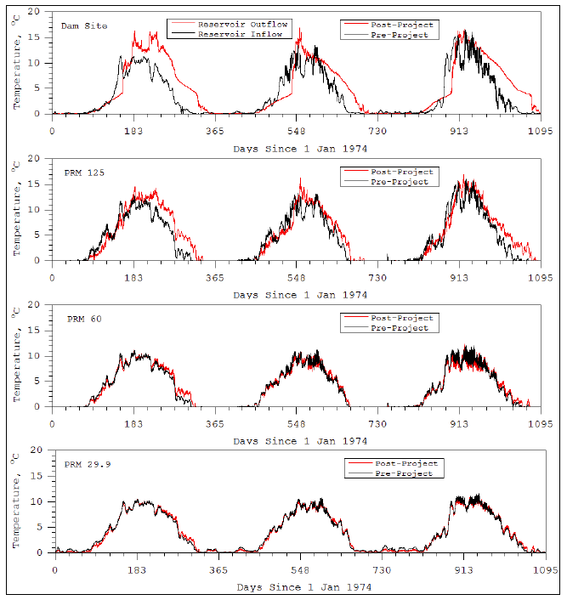

Figure 3-2. Comparison of pre-Project (1974-1976) and post-Project (maximum load following scenario) river temperature along the Susitna River at the dam site, PRM 125, PRM 60 and PRM 29.9.

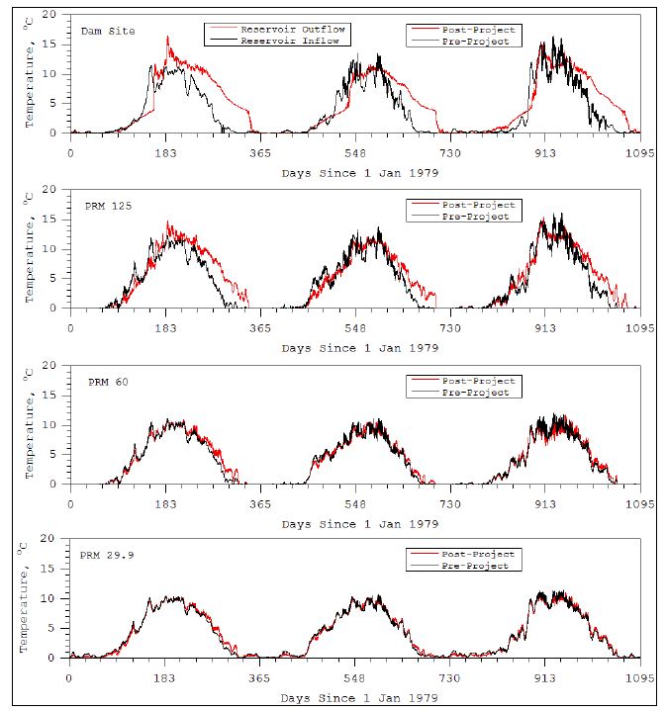

Figure 3-3. Comparison of pre-Project (1979-1981) and post-Project (maximum load following scenario) river temperature along the Susitna River at the dam site, PRM 125, PRM 60 and PRM 29.9.

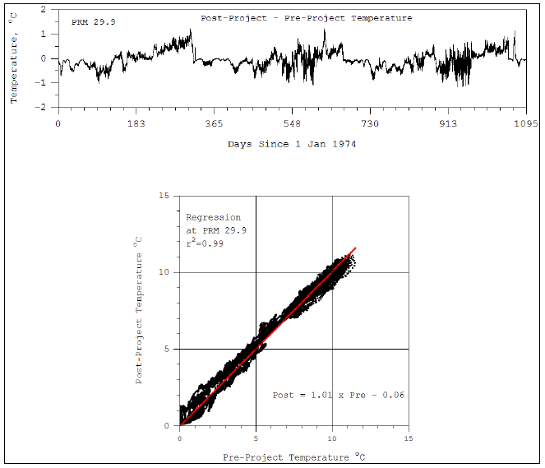

Figure 3-4. Daily variation in temperature at PRM 29.9 for pre-Project (1974-1976) and post-Project maximum load following conditions.

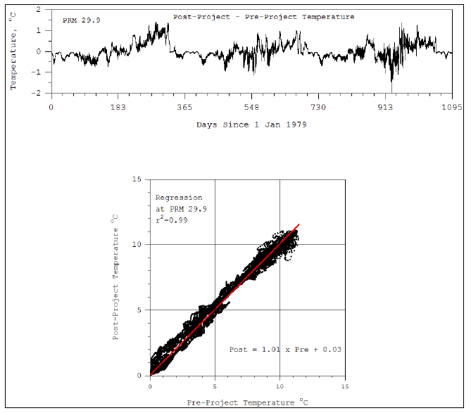

Figure 3-5. Daily variation in temperature at PRM 29.9 for pre-Project (1979-1981) and post-Project maximum load following conditions.

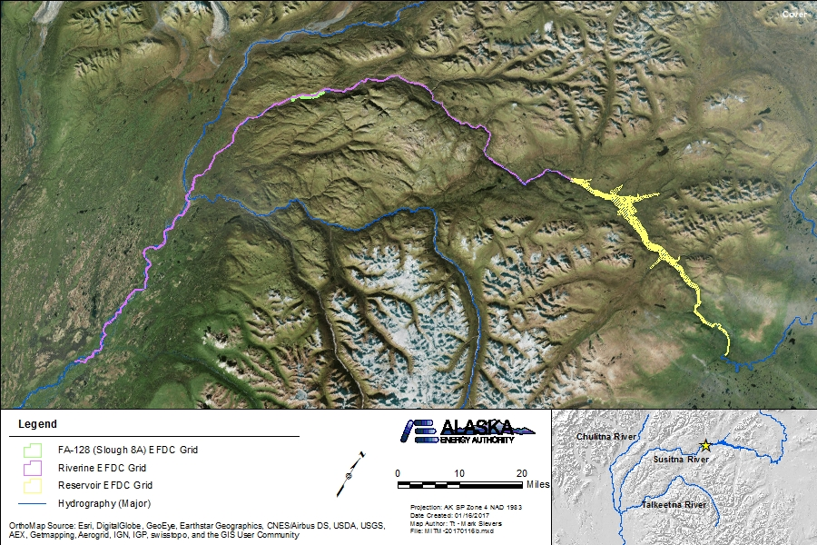

Figure 4.4-1. Study 5.6 Riverine, Reservoir, and FA-128 (Slough 8A) EFDC model grid extents.

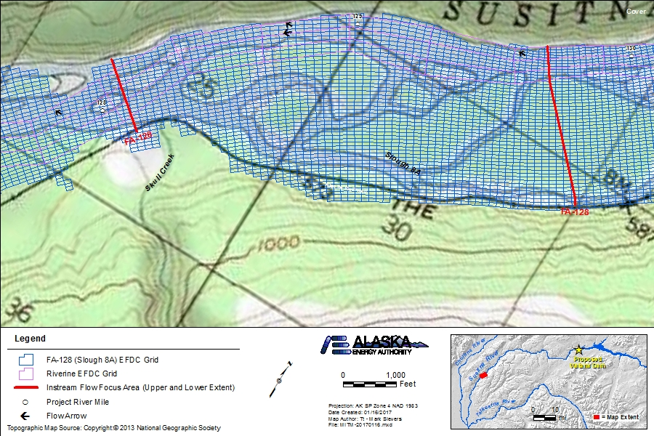

Figure 4.4-2. Study 5.6 FA-128 (Slough 8A) EFDC model grid extent detail.

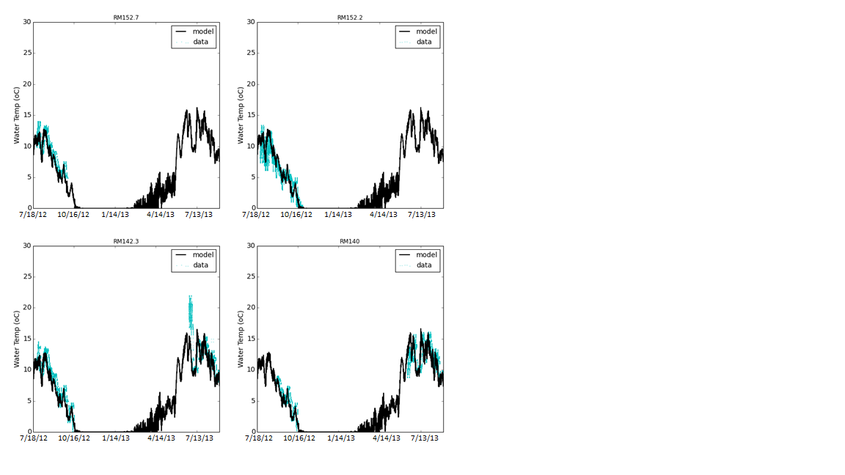

Figure 5.1-1. River Model temperature calibration plots (PRM 152.7, 152.2, 142.3, 140).

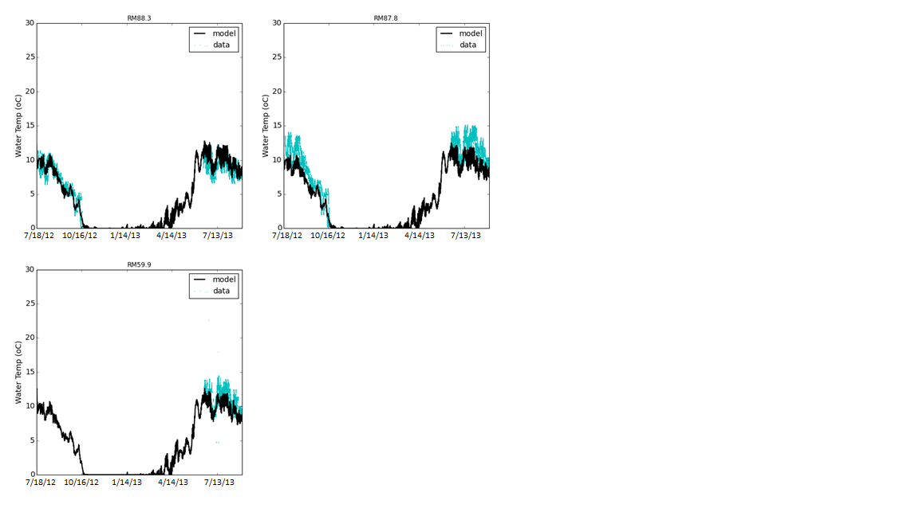

Figure 5.1-2. River Model temperature calibration plots (PRM 88.3, 87.8, 59.9).

|  |  |
| --- | --- |
| Figure 5.1-3 River Model DO calibration plot at PRM 29.9. | Figure 5.1-4 River Model DO calibration plot at PRM 33.6. |
| Figure 5.1-5 River Model DO calibration plot at PRM 59.9. | Figure 5.1-6 River Model DO calibration plot at PRM 87.8. |
| Figure 5.1-7 River Model DO calibration plot at PRM 107. | Figure 5.1-8 River Model DO calibration plot at PRM 124.2. |

|  |  |
| --- | --- |
| Figure 5.1-9 River Model DO calibration plot at PRM 142.3. | Figure 5.1-10 River Model DO calibration plot at PRM 152.7. |
| Figure 5.1-11 River Model DO calibration plot at PRM 174. | Figure 5.1-12 River Model sediment calibration plot at PRM 29.9. |
| Figure 5.1-13 River Model sediment calibration plot at PRM 32.5. | Figure 5.1-14 River Model sediment calibration plot at PRM 33.6. |

|  |  |
| --- | --- |
| Figure 5.1-15 River Model sediment calibration plot at PRM 45.1. | Figure 5.1-16 River Model sediment calibration plot at PRM 59.9. |
| Figure 5.1-17 River Model sediment calibration plot at PRM 87.8. | Figure 5.1-18 River Model sediment calibration plot at PRM 102.8. |
| Figure 5.1-19 River Model sediment calibration plot at PRM 107. | Figure 5.1-20 River Model sediment calibration plot at PRM 118.6. |

|  |  |
| --- | --- |
| Figure 5.1-21 River Model sediment calibration plot at PRM 124.2. | Figure 5.1-22 River Model sediment calibration plot at PRM 140.1. |
| Figure 5.1-23 River Model sediment calibration plot at PRM 142.2. | Figure 5.1-24 River Model sediment calibration plot at PRM 142.3. |
| Figure 5.1-25 River Model sediment calibration plot at PRM 152.3. | Figure 5.1-26 River Model sediment calibration plot at PRM 152.7. |

|  |  |
| --- | --- |
| Figure 5.1-27 River Model sediment calibration plot at PRM 174. | Figure 5.1-28 River Model sediment calibration plot at PRM 187.2. |

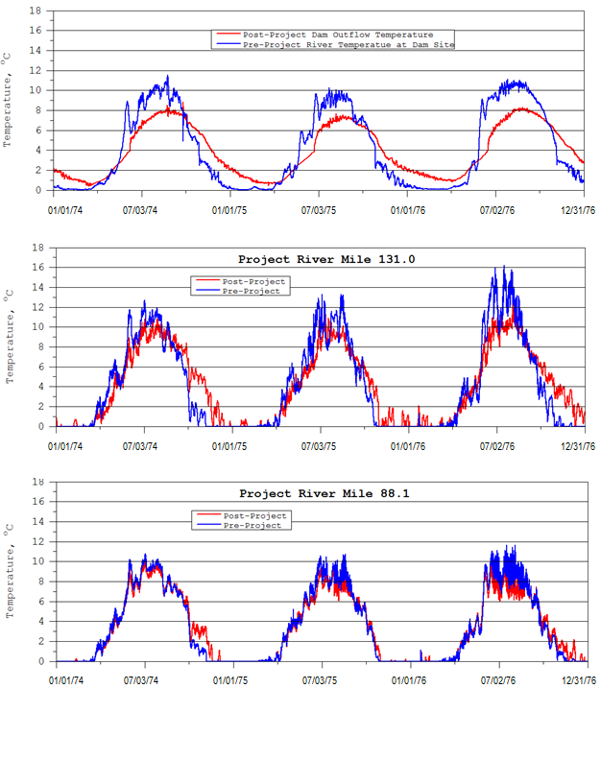

Figure 5.4-1. 1974–1976 Simulation boundary conditions River Model temperature results.

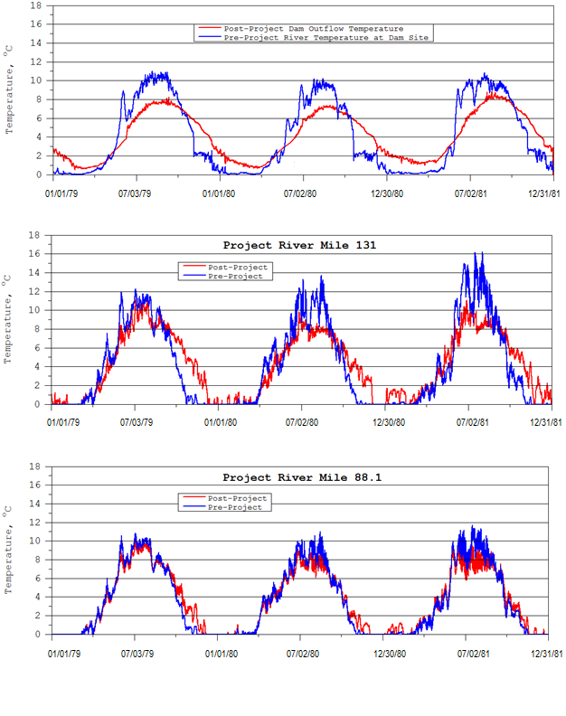

Figure 5.4-2. 1976–1981 Simulation boundary conditions River Model temperature results.

|  |  |
| --- | --- |
|  |  |
|  |  |

Top left–06/16/76 (midnight); Top right–06/20/76 (midnight); Bottom left–06/24/76 (midnight); Bottom right-06/28/76 (noon)

Figure 5.4-3. Example temperature plots of FA-128 (Slough 8A) EFDC model results.

|  |  |
| --- | --- |
|  |  |
|  |  |

Figure 5.4-4. Upstream/Downstream FA-128 boundary comparisons for pre-and post-Project scenarios.