Baseline Field Data

Field data were collected at all baseline monthly water quality monitoring sites along the Susitna River from June to September 2013. Data was collected monthly at 22 stations along the Susitna River for the following parameters

* Color
* Temperature
* Dissolved oxygen
* pH
* Specific conductivity, and
* Redox potential.

The data were measured at the left, middle and right across the cross-section and at various depths at each of these three locations across the river. An inventory of the station locations is provided below in Table 1 and show in Figure 1.

Table 1. Baseline Field Data collected along and the Susitna and its tributaries

|  |  |  |  |  |  |  |  |
| --- | --- | --- | --- | --- | --- | --- | --- |
| PRM | Site Name | Latitude | Longitude | Dt_Coll_1 | Dt_Coll_2 | Dt_Coll_3 | Dt_Coll_4 |
| 29.9 | Susitna Station | 61.5443 | -150.5156 | 6/25/2013 | 7/19/2013 | 8/18/2013 | 9/15/2013 |
| 32.5 | Yentna River | 61.5876 | -150.4997 | 6/25/2013 | 7/19/2013 | 8/18/2013 | 9/15/2013 |
| 33.6 | Susitna above Yentna | 61.5759 | -150.4272 | 6/27/2013 | 7/20/2013 | 8/19/2013 | 9/16/2013 |
| 45.1 | Deshka River | 61.7102 | -150.3238 | 6/28/2013 | 7/19/2013 | 8/19/2013 | 9/16/2013 |
| 59.9 | Susitna | 61.8609 | -150.1849 | 6/29/2013 | 7/19/2013 | 8/19/2013 | 9/17/2013 |
| 87.8 | Susitna at Parks Highway East | 62.1747 | -150.1735 | 6/21/2013 | 7/17/2013 | 8/17/2013 | 9/14/2013 |
| 103 | Talkeetna River | 62.3419 | -150.1115 | 6/22/2013 | 7/15/2013 | 8/16/2013 | 9/9/2013 |
| 107 | Talkeetna | 62.3978 | -150.1338 | 6/21/2013 | 7/18/2013 | 8/16/2013 | 9/9/2013 |
| 119 | Chulitna River | 62.5675 | -150.2381 | 6/24/2013 | 7/16/2013 | 8/17/2013 | 9/13/2013 |
| 124 | Curry Fishwheel Camp | 62.6171 | -150.0121 | 6/22/2013 | 7/18/2013 | 8/15/2013 | 9/10/2013 |
| 140 | Gold Creek | 62.7679 | -149.6898 | 6/23/2013 | 7/17/2013 | 8/17/2013 | 9/10/2013 |
| 142 | Indian River | 62.7838 | -149.6576 | 6/23/2013 | 7/16/2013 | 8/14/2013 | 9/11/2013 |
| 142 | Susitna above Indian River | 62.7856 | -149.6487 | 6/24/2013 | 7/15/2013 | 8/13/2013 | 9/11/2013 |
| 152 | Portage Creek | 62.8302 | -149.3839 | 7/30/2013 | 8/14/2013 | 9/12/2013 |  |
| 153 | Susitna above Portage Creek | 62.8275 | -149.369 | 7/30/2013 | 8/14/2013 | 9/12/2013 |  |
| 174 | Susitna below Watana Dam Site | 62.7667 | -148.8539 | 8/18/2013 | 8/31/2013 | 9/20/2013 |  |
| 187 | Susitna at Watana Dam Site | 62.8258 | -148.5231 | 8/18/2013 | 7/2/2013 | 7/22/2013 | 8/31/2013 |
| 235 | Oshetna Creek | 62.6403 | -147.3837 | 7/2/2013 | 7/22/2013 | 8/31/2013 | 9/20/2013 |

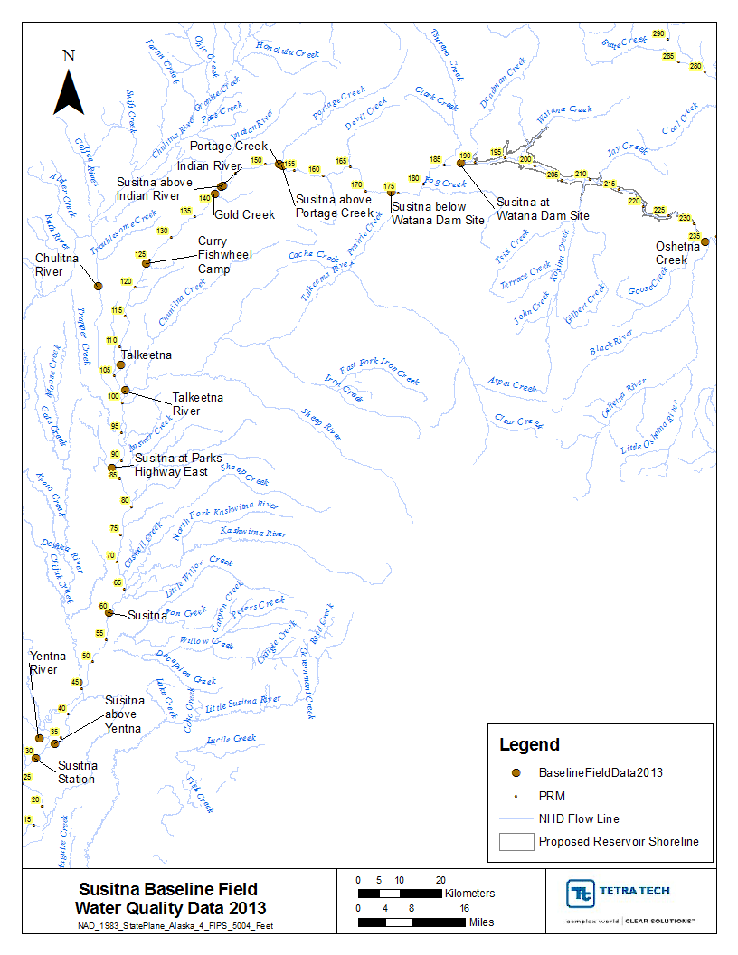

Figure 1. Baseline field water quality data (2013)

Variation across the width was found to be limited and in order to evaluate the observed data the field data were averaged across the width at each depth and plotted longitudinally along the river by month. The incoming tributaries were also plotted in the same manner along the main stem to evaluate the magnitude and response of each of the tributaries. The observed temperature, dissolved oxygen and pH data along the Susitna are presented by month in Figure 2, Figure 3, and Figure 4.

In general the observed variation across the depth was also found to be minimal with temperatures variations being less than 1 degree C, DO less than 0.5 mg/L, and pH being less than 0.25 units. Notable exceptions along the depth were seen at PRM 187 Susitna at Watana, where the temperatures varied around 5 degrees C, and DO by 1.5 mg/L during August, and to lesser extent at Susitna above Yentna PRM 33.6 where there was some vertical variation (2 degrees C during June and August) and at PRM 174 Susitna below Watana Dam site where the DO varied by around 1.5 mg/L along the depth.

Observed temperatures indicate that Chulitna River inputs were consistently much cooler (around 6 degrees C) compared to all tributaries, whereas Deshka River showed the highest tributary input temperature of 20 degrees C observed during June. Observed temperatures along the mainstem were almost always under 15 degrees C. However, by September the temperatures at all locations are fairly similar i.e. <10 degrees C, averaging around 8 degrees C with the upstream headwater being the coldest.

Observed DO was almost always above 10 mg/L during June, July, August, and September along the Susitna main stem and in its tributaries. The tributary DO concentrations from Chulitna River were always high for all months compared to all locations. DO saturation values were also calculated using the observed temperature at all the monitored locations and plotted along with the observed dissolved oxygen. An average DO saturation trend line (polynomial fit) was also plotted for comparison purposes (Figure 3). Observed DO was typically 64 percent of the time above the calculated saturation value during 2013. In June the observed DO was above saturation 100 percent of the time, and for the rest of the months i.e. July, August and September the observed DO was calculated to be 60, 50, and 53 percent of the time above the calculated DO saturation value respectively. Although as can be seen from the DO plots for these months even though the DO was 50 percent of the time above saturation, the DO was relatively closer to the DO saturation value. Except for Talkeetna River (PRM 103) all other tributary inputs were always above the DO saturation value.

No pH measurements were made during June. In general most of the locations were within the desired range of less than 8.5 and greater than 6.5 for the monthly of July, August and September (Figure 4). No exceedences occurred during September. A few locations showed exceedences that were above the 8.5 limit with the majority occurring during August followed by a few in July. Along the main stem the exceedences were <0.2 pH units above the 8.5 limit, which were primarily observed at Susitna -PRM 59.9, and at Susitna above Indian River -PRM 142. Tributary input from PRM 119 Chulitna River was above the 8.5 limit in July and August, whereas PRM 140 Gold Creek exceeded the 8.5 limit during August.

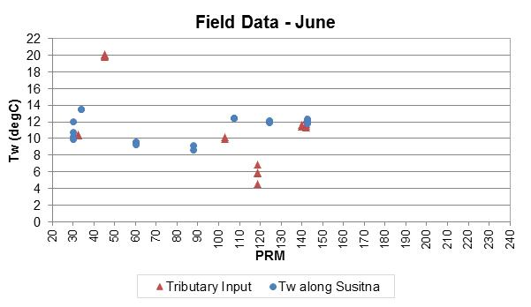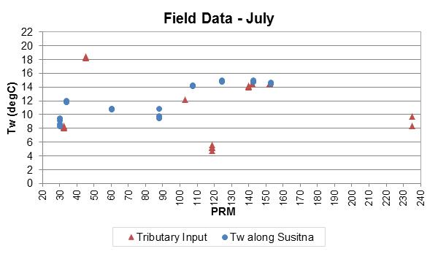

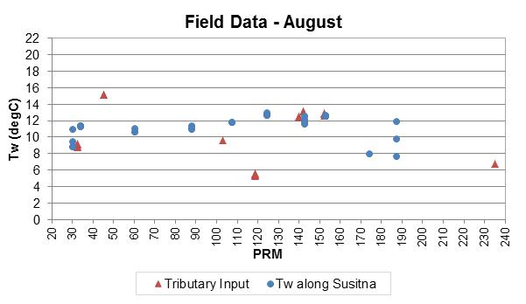

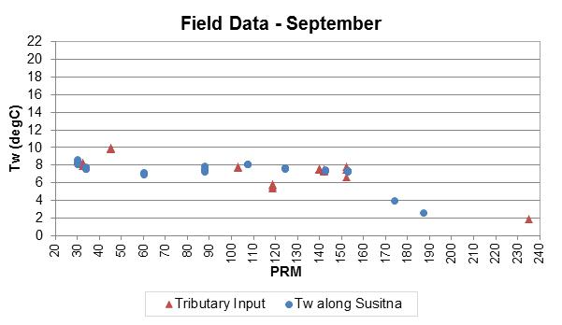

Figure 2. Baseline field water temperature (width averaged) – 2013

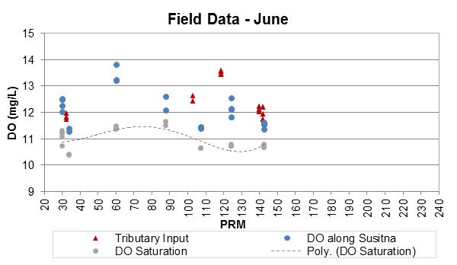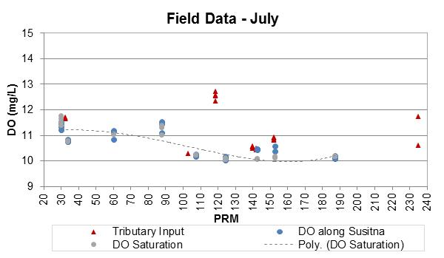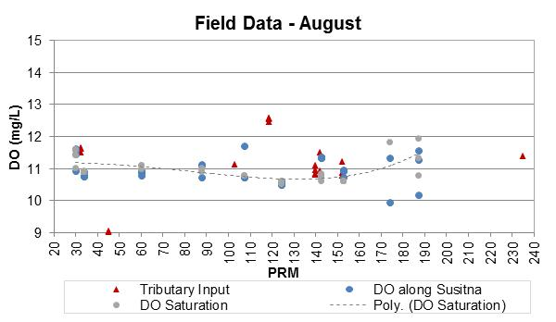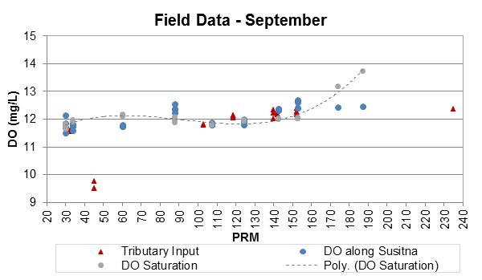

Figure 3. Baseline field dissolved oxygen (width averaged) - 2013

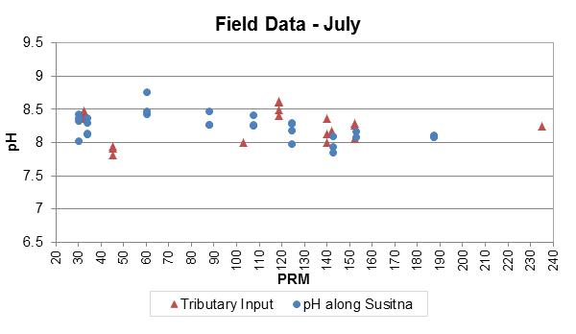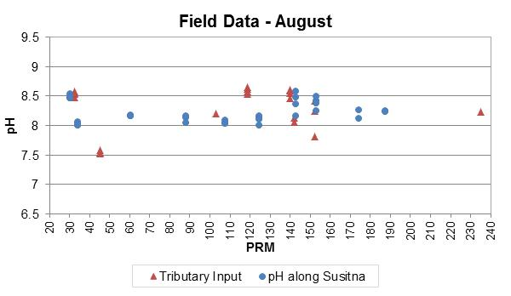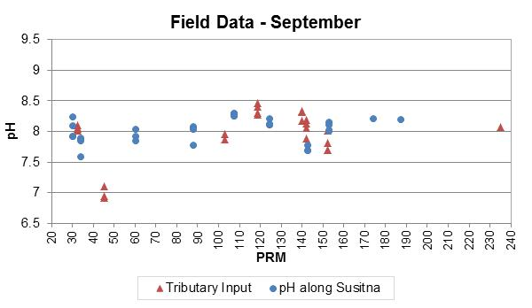

Figure 4. Baseline field pH (width averaged) – 2013