# comprehensive Data delivery README FILE

|  |  |
| --- | --- |
| **Study Section** | Study 6.6: Fluvial Geomorphology (FGM) |
| **Study Component** | (1) Bed Evolution Model Development, Coordination, and Calibration |
| **Prepared By** | Tetra Tech, Inc. |
| **Data Collection and Processing By** | Matanuska-Susitna Borough/Kodiak Mapping/Tetra Tech, Inc. |
| **Field Date Range** | June 2011; September – November 2013; May – June 2014 |

**Introduction:** The overall goal of the Fluvial Geomorphology Modeling below Watana Dam Study is to model the effects of the proposed Susitna-Watana Hydroelectric Project (the Project) on the fluvial geomorphology of the Susitna River and to assist in predicting the trend and magnitude of geomorphic response. More specifically, the purpose of the modeling study, along with the Geomorphology Study (Study 6.5), is to assess the potential impact of the Project on the behavior of the river downstream of the proposed dam, with particular focus on potential changes in instream and riparian habitat.

The goal of the study component “Bed Evolution Model Development, Coordination, and Calibration” is to develop calibrated models to predict the magnitude and trend of geomorphic response to the Project and apply the developed models to estimate the potential for channel change for with-Project operations compared to existing conditions.

LiDAR data sets were acquired and indexed in 2011, 2013, and 2014 in order to support model development.

**Data Summary:** Three LiDAR data sets are available for various portions of the Susitna River. The Matanuska-Susitna Borough (Mat-Su) LiDAR was acquired in 2011, Tetra Tech Indexed the 2011 Mat-Su LiDAR data and AEA acquired higher density LiDAR in 2013 and 2014 (SuWa LiDAR). The original Mat-Su LiDAR was not indexed or verified using surveyed ground points. AEA decided to acquire the high-density LiDAR (Su-Wa LiDAR) to provide more accurate information, but unfavorable conditions limited the amount of LiDAR that was acquired in 2013. Therefore, in order to supplement the 2013 LiDAR data, the Mat-Su LiDAR was indexed and verified using 2013 ground survey data. This approach resulted in the best available LiDAR for use until additional LiDAR could be obtained in 2014. Additional LiDAR was then collected in the spring of 2014.

Details of the LiDAR are identified below:

**2011 Indexed Mat-Su LiDAR**

* Spans the Lower and Middle Susitna River segments from PRM 29 to PRM 188
* Indexed using ground survey points from 2013
* Delivered data includes Unclassified las files, classified las files, DEM, tile index, and metadata

**2013 SuWa LiDAR**

* LiDAR data acquisition occurred between September 9, 2013 and November 8, 2013.
* Covers 107.7 sq. mi over most of the Lower Susitna River Segment, Three Rivers Confluence and a smaller section upstream of the Three Rivers Confluence in the Middle Susitna River Segment
* Delivered data includes:

1. **PA-01 South (folder):** Unclassified las files, classified las files, DEM, tile index, and metadata. *Data Extents: PRM 102 to PRM 107*
2. **PA-07 (folder):** Unclassified las files, classified las files, DEM, tile index, and metadata. *Data Extents: PRM 65 to PRM 97*
3. **PRM_97_to_102_confluence (folder):** Unclassified las files, classified las files, DEM, tile index, and metadata. *Data Extents: PRM 97 to Three rivers Confluence at PRM 102*

**2014 SuWa LiDAR**

* LiDAR data acquisition occurred between May 21, 2014 and June 3, 2014.
* Covers 38 sq. mi along the Middle Susitna River Segment and 185 sq. mi near the proposed reservoir (shown in Figure 1).
* Delivered data includes:

1. **Block 01 (folder):** Unclassified las files, classified las files, DEM, tile index, and metadata. *Data Extents: PRM 107 to PRM 146*
2. **Block 02 (folder):** Unclassified las files, classified las files, DEM, tile index, and metadata. *Data Extents: PRM 146 to PRM 18*
3. **Area_1 (folder):** Unclassified las files, classified las files, DEM, tile index, and metadata. *Data Extents: PRM 175 to PRM 195*
4. **Area_2_3a (folder):** Unclassified las files, classified las files, DEM, tile index, and metadata. *Data Extents: PRM 185 to PRM 202*

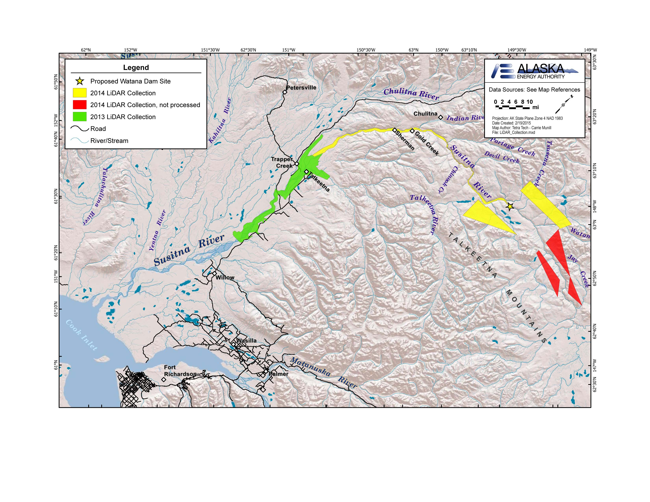

Figure 1: 2013 and 2014 LiDAR areas and collection.

**Data Organization:** None.

**Software or Hardware Considerations:** None.

**Online Data Link:** All LiDAR data sets are located at the Geographic Information Network of Alaska (GINA) hosted website for Susitna-Watana Project data.

**Mat-Su 2011 LiDAR data** is nested under “Raster Data” and found at the following url: <http://suwa.portal.gina.alaska.edu/raster-data>

Or can be accessed directly at: <http://matsu.gina.alaska.edu/>

**Indexed Mat-Su 2011 LiDAR data** is nested under “Raster Data” and found at the following url:

Or can be accessed directly at: <http://gis.suhydro.org/catalogs/11872-2011-matsu-indexed-lidar>

**SuWa 2013 LiDAR data** can be accessed at the following url: <http://gis.suhydro.org/pub/>

Or can be accessed directly at: <http://gis.suhydro.org/pub/2013_Lidar/>

**SuWa 2014 LiDAR data** can be accessed at the following url: <http://gis.suhydro.org/pub/>

Or can be accessed directly at: <http://gis.suhydro.org/pub/2014_Lidar/>

**Online Report Link:**

2011 and 2013 LiDAR data are further discussed in the Study 6.6 Initial Study Report:

**“**6.6 Fluvial Geomorphology Modeling below Watana Dam Study” under June 3, 2014; Initial Study Report – Part A, B, and C at <http://www.susitna-watanahydro.org/type/documents/> . *There are a total of 3 links associated with this report. There is one link for the following: (1) Main body text and tables [Part A 1 of 3], (2) Figures [Part A 2 of 3], and (3) Appendices and Attachment [Part A 3 of 3].*

2014 LiDAR data are further discussed in the Study 6.6 Study Implementation Report:

“06.06 Fluvial Geomorphology Modeling below Watana Dam – 2014-2015 Study Implementation Report (Part 1 of 4)” under November 2015; Study Completion and 2014/2015 Implementation Reports at <http://www.susitna-watanahydro.org/type/documents/> . *There are multiple links associated with this report filing, however the link noted as “Part 1 of 4” is the most relevant to the LiDAR data.*

**[1]**

1. **Data Distributor Contact Information:**

   Alaska Energy Authority, 813 West Northern Lights Boulevard, Anchorage, AK 99503

   Voice: 907-771-3000, Email: [SUWAhelp@aidea.org](mailto:SUWAhelp@aidea.org)

   **Legal Constraints:** The electronic services or products are provided "AS IS", WITHOUT WARRANTY OF ANY KIND, EXPRESS OR IMPLIED, INCLUDING BUT NOT LIMITED TO THE WARRANTIES OF MERCHANTABILITY, FITNESS FOR A PARTICULAR PURPOSE AND NONINFRINGEMENT. IN NO EVENT SHALL THE Alaska Energy Authority, the State of Alaska, or their respective employees or agents, BE LIABLE FOR ANY CLAIM, DAMAGES OR OTHER LIABILITY, WHETHER IN AN ACTION OF CONTRACT, TORT OR OTHERWISE, ARISING FROM, OUT OF OR IN CONNECTION WITH use of the electronic services or products, any failure thereof or otherwise, and in no event will the State of Alaska's liability to the requestor or anyone else exceed the fee paid for the electronic service or product.