Survey Date: October 12-18, 2012
Final Delivery: February 14, 2013

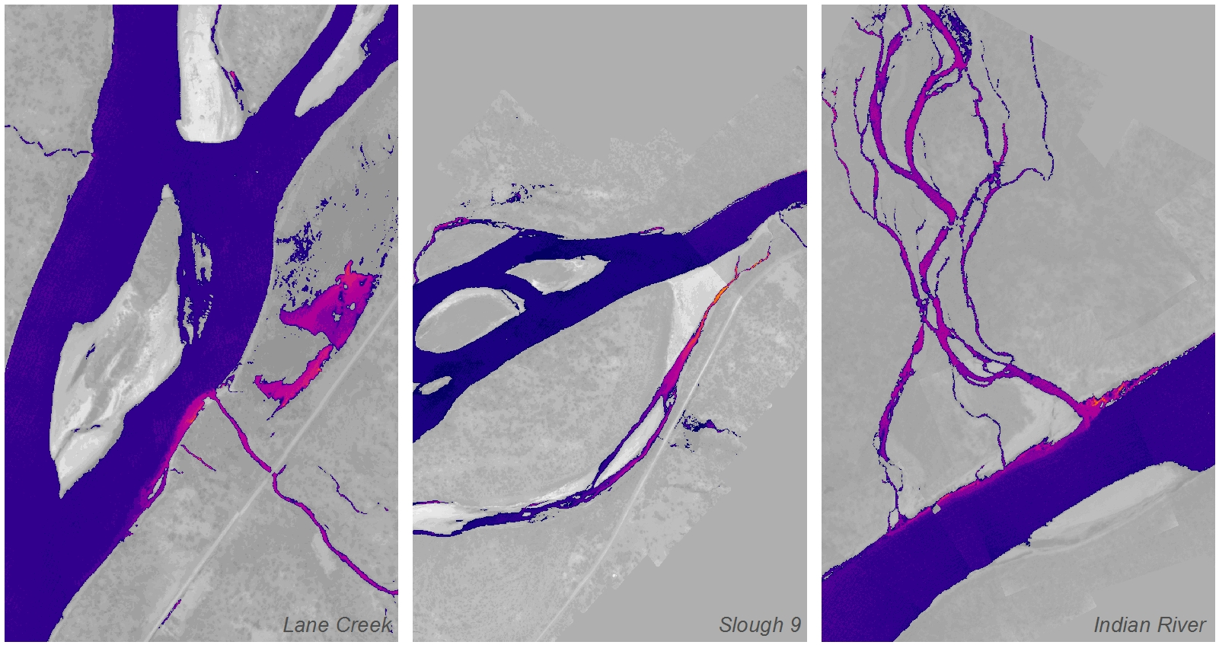

Susitna River, Alaska
Airborne Thermal Infrared Remote Sensing
WSI Corvallis Office
517 SW 2nd St., Suite 400
Corvallis, OR 97333
Phone: 541-752-1204
Paul Dworian
URS Geosciences & Remediation Services
700 G Street
Suite 500
Anchorage, AK 99501
Phone: 907-562-3366

Table of Contents
1. Introduction 1
2. Acquisition 3
2.1. Instrumentation 3
2.2. Image Collection 4
2.3. Ground Control 5
2.4. Weather and Flow Conditions 6
3. Thermal Image Characteristics 7
3.1. Surface Temperatures 7
3.2. Expected Accuracy 7
3.3. Image Uniformity 7
3.4. Temperatures and Color ramps 8
4. Data Processing 9
4.1. Sensor Calibration 9
4.2. Geo-referencing 9
4.3. Geo-rectification 9
4.4. Interpretation and Sampling 9
4.5. Temperature Profiles 10
5. Thermal Accuracy 11
6. Discussion 13
7. Summary 17
7.1. Deliverables 17

Introduction
WSI (Watershed Sciences, Inc.) was contracted by the URS Corporation to collect airborne thermal infrared (TIR) imagery in late 2012 for the Susitna River from the confluence with the Chulitna River upstream for 88 miles to Deadman Creek (Figure 1). The survey was conducted over a 4-day period in October 2012. To maximize thermal contrast between warmer ground water discharge and colder river temperatures of the Susitna, the TIR sensor was flown during early morning when solar loading was minimized. Collected stream reaches and extents are listed in Table 1.

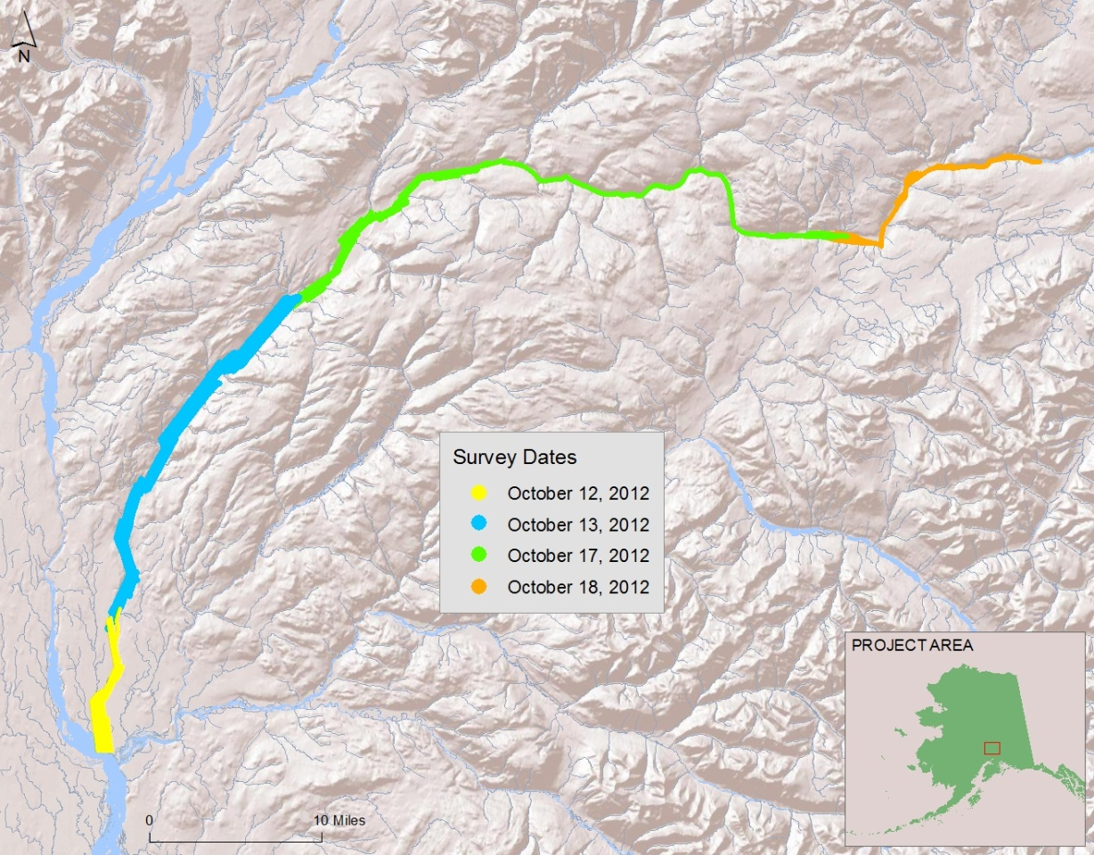
- River reaches surveyed for the Susitna River

- Stream reaches and acquisition dates
Survey Date | Approximate River Miles Flown
10/12/2012 | 9
10/13/2012 | 23
10/17/2012 | 37
10/18/2012 | 19
Total: | 88

Airborne TIR remote sensing has proven to be an effective method for mapping spatial temperature patterns in rivers and streams. These data are used to establish baseline conditions and direct future ground level monitoring. The TIR imagery illustrates the location and thermal influence of point sources, tributaries, and surface springs. When combined with other spatial data sets, TIR data also illustrate reach-scale thermal responses to changes in morphology, vegetation, and land use.
The thermal differential between bulk water temperatures in the Susitna and subsurface discharges are approximately 3°C during the fall months with the ground water discharge typically being warmer than in-stream temperatures. The primary goal of the acquisition was to map the spatial dynamics and magnitude of groundwater discharge to establish baseline data for assessing the availability and spatial extent of thermal refugia for salmonids in the middle Susitna River.

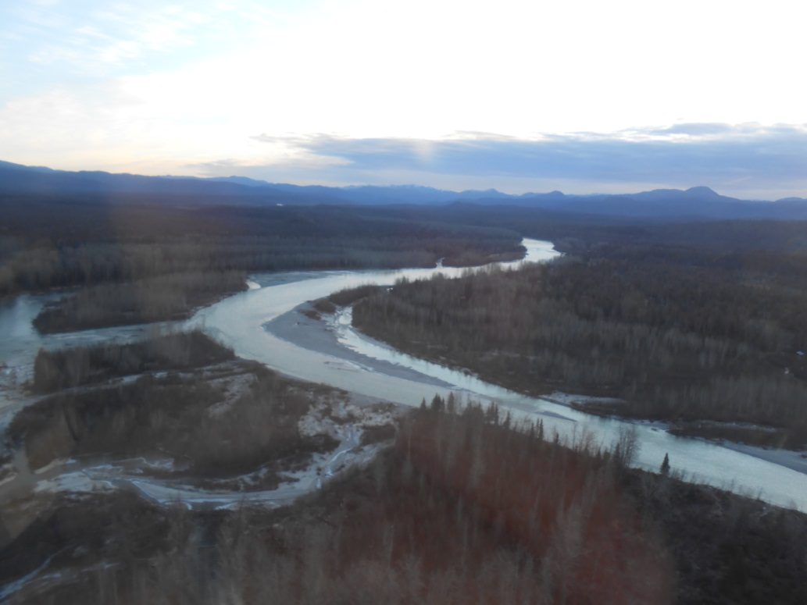
Susitna River

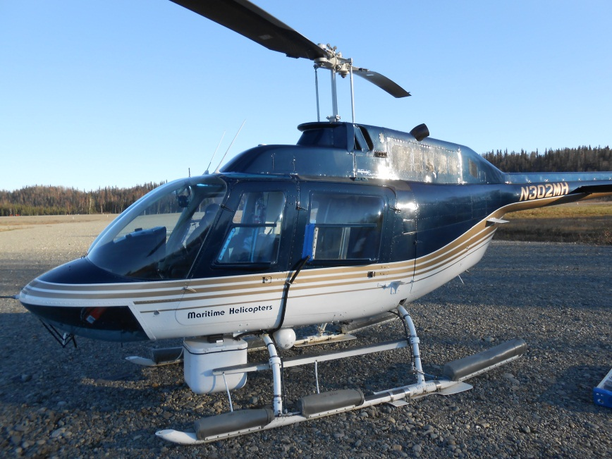
Acquisition
FLIR Sensor

Bell Jet Ranger equipped with mounted FLIR sensor

Instrumentation
Images were collected with a FLIR system’s SC6000 sensor (8-9.2μm) mounted on the underside of a Bell Jet Ranger Helicopter. The SC6000 is a calibrated radiometer with internal non-uniformity correction and drift compensation. The sensor is contained in a composite fiber enclosure attached to the underside of the helicopter which is flown longitudinally along the stream channel. General specifications of the thermal infrared sensor are listed in Table 2.

- Summary of TIR sensor specifications
FLIR System SC6000 (LWIR)
Wavelength: | 8-9.2 μm
Noise Equivalent Temperature Differences (NETD): | 0.035°C
Pixel Array: | 640 (H) x 512 (V)
Encoding Level: | 14 bit
Horizontal Field-of-View: | 35.5°

Image Collection
Due to the river’s width, the aircraft was flown in parallel flight lines in order to capture the full floodplain extent of the Susitna River. The flight lines were designed for an image side-lap of 40% and the TIR sensor was set to acquire images at a rate of 1 image every second resulting in an image overlap of approximately 65%. Narrower reaches upstream were collected with a single flight pass.
The TIR data acquisition was conducted at a flight altitude of 2300 feet above ground level (AGL) resulting in pixel resolution of 2.3 ft (0.70 m). A summary of acquisition parameters and flight times can be seen in Table 3. Due to terrain variations, wind conditions, and stream size, altitudes can vary throughout the flight duration. A summary of flight acquisition parameters can be seen in Table 3.

- Summary of Thermal Image Acquisition Parameters
Acquisition Parameters
Dates: | October 12,13,17,18, 2012
Flight Above Ground Level (AGL): | 2300 feet
Image Footprint Width: | 1472 feet (449 meters)
Pixel Resolution: | 2.3 feet (0.7 meters)

Thermal infrared images were recorded directly from the sensor to an on-board computer as raw counts which were then converted to radiant temperatures. The individual images were referenced with time, position, and heading information provided by a global positioning system (GPS) (Figure 2).
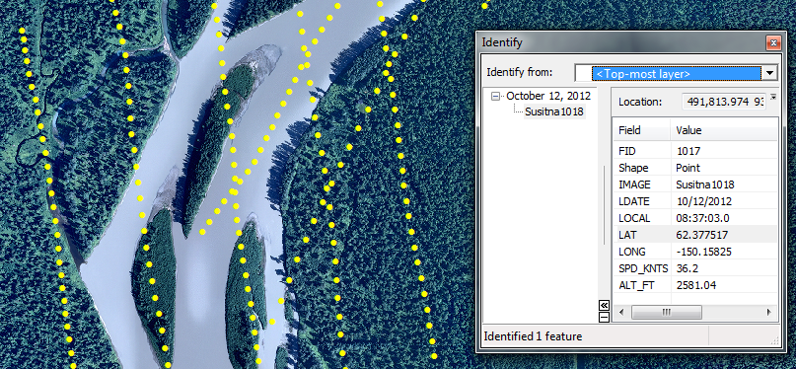
- Each point on the map represents a thermal image location. The inset box shows the information recorded with each image during acquisition.

Ground Control
WSI utilized data provided by URS from 6 in-stream sensors in the mainstem Susitna for calibrating and verifying the thermal accuracy of the TIR imagery. Data for other sensor locations in the River were either not available for the dates of the surveys or were in areas of increased thermal mixing and could not be used for calibration purposes. Data logger locations are illustrated in Figure 3.
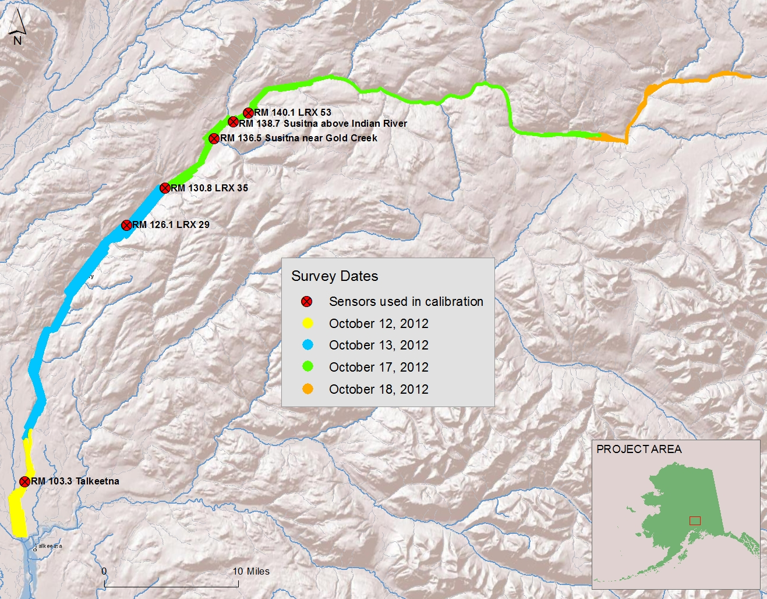
- Locations of sensors used for calibration

Weather and Flow Conditions
Weather conditions on the mornings of the survey were considered ideal for detecting groundwater inflows to the Susitna River with cold temperatures, low humidity and clear skies. Table 4 summarizes the weather conditions observed in Talkeetna, AK (Station ID: CYFC) on the survey dates. No flights were conducted on October 14-16, 2012 due to warmer temperatures and low clouds in the area.
- Weather Conditions on the survey dates in Talkeetna, Alaska
Time (ADT) | Air Temp. (°C) | Humidity | Wind Direction | Wind Speed | Conditions
12-October-2012
5:53 AM | 30.0°F | 51% | Calm | Calm | Clear
6:53 AM | 27.0°F | 61% | Calm | Calm | Clear
7:53 AM | 28.0°F | 56% | North | 5.8 mph | Clear
9:53 AM | 30.0°F | 49% | North | 4.6 mph | Clear
10:53 AM | 33.1°F | 46% | North | 4.6 mph | Clear
13-October-2012
5:53 AM | 28.9 °F | 47% | North | 4.6 mph | Clear
6:53 AM | 28.9 °F | 47% | North | 4.6 mph | Clear
7:53 AM | 28.9 °F | 45% | North | 4.6 mph | Clear
8:53 AM | 28.0 °F | 47% | Calm | Calm | Clear
9:53 AM | 27.0 °F | 53% | North | 4.6 mph | Clear
17-October-2012
5:53 AM | 26.1 °F | 92% | Calm | Calm | Clear
6:53 AM | 21.9 °F | 96% | Calm | Calm | Clear
7:53 AM | 19.9 °F | 100% | Calm | Calm | Clear
8:53 AM | 19.0 °F | 92% | Calm | Calm | Clear
9:53 AM | 21.0 °F | 92% | Calm | Calm | Partly Cloudy
18-October-2012
5:53 AM | 14.0 °F | 88% | Calm | Calm | Clear
6:53 AM | 14.0 °F | 88% | Calm | Calm | Clear
7:53 AM | 15.1 °F | 84% | NNW | 3.5 mph | Clear
8:53 AM | 16.0 °F | 88% | Calm | Calm | Clear
9:53 AM | 23.0 °F | 68% | NNW | 5.8 mph | Clear

Thermal Image Characteristics

Surface Temperatures
Thermal infrared sensors measure TIR energy emitted at the water’s surface. Since water is essentially opaque to TIR wavelengths, the sensor is only measuring water surface temperatures. Thermal infrared data accurately represents bulk water temperatures where the water column is thoroughly mixed; however, temperature differences can form in the vertical water column in reaches that have little or no mixing. Given the cold temperatures, it is possible that ice was present in areas of the survey.

Expected Accuracy
Thermal infrared radiation received at the sensor is a combination of energy emitted from the water’s surface, reflected from the water’s surface, and absorbed and re-radiated by the intervening atmosphere. Water is a good emitter of TIR radiation and has relatively low reflectivity (~ 4 to 6%). In general, apparent stream temperature changes of < 0.5°C are not considered significant unless associated with a surface inflow (e.g. tributary). However, certain conditions may cause variations in the accuracy of the imagery.
Surface Conditions
Variable water surface conditions (i.e. riffle versus pool), slight changes in viewing aspect, and variable background temperatures (i.e. sky versus trees) can result in differences in the calculated radiant temperatures within the same image or between consecutive images. The apparent temperature variability is generally less than 0.5°C (Torgersen et al. 2001). The occurrence of reflections as an artifact (or noise) in the TIR images is a consideration during image interpretation and analysis.
Feature Size and Resolution
A small stream width logically translates to fewer pure stream pixels and greater integration with non-water features such as rocks and vegetation. Consequently, a narrow channel (relative to the pixel size) can result in higher variability and inaccuracies in the measured radiant temperatures as more ‘mixed pixels’ are sampled. This is a consideration especially when sampling the radiant temperatures at tributary mouths and surface springs.

Image Uniformity
The TIR sensor used for this study uses a focal plane array of detectors to sample incoming radiation. A challenge when using this technology is to achieve uniformity across the detector array. The sensor has a correction scheme which reduces non-uniformity across the image frame; however, differences in temperature (typically <0.5°C) can be observed near the edge of the image frame. The uniformity differences within frames and slight differences from frame-to-frame are most apparent in the continuous mosaics.

Temperatures and Color ramps
The TIR images collected during this survey consist of a single band. As a result, visual representation of the imagery (in a report or GIS environment) requires the application of a color ramp or legend to the pixel values. The selection of a color ramp should highlight features most relevant to the analysis (i.e. spatial variability of stream temperatures). For example, a continuous, gradient style color ramp that incorporates all temperatures in the image frame will provide a smoother transition in colors throughout the entire image, but will not highlight temperature differences in the stream. Conversely, a color ramp that focuses too narrowly cannot be applied to the entire river and will washout terrestrial and vegetation features (Figure 4).
The color ramps for the TIR mosaics were developed to maximize the contrast of the majority of the surface water features and are unique by date. The color ramp can be modified by the end user to highlight features or temperature ranges of interest.

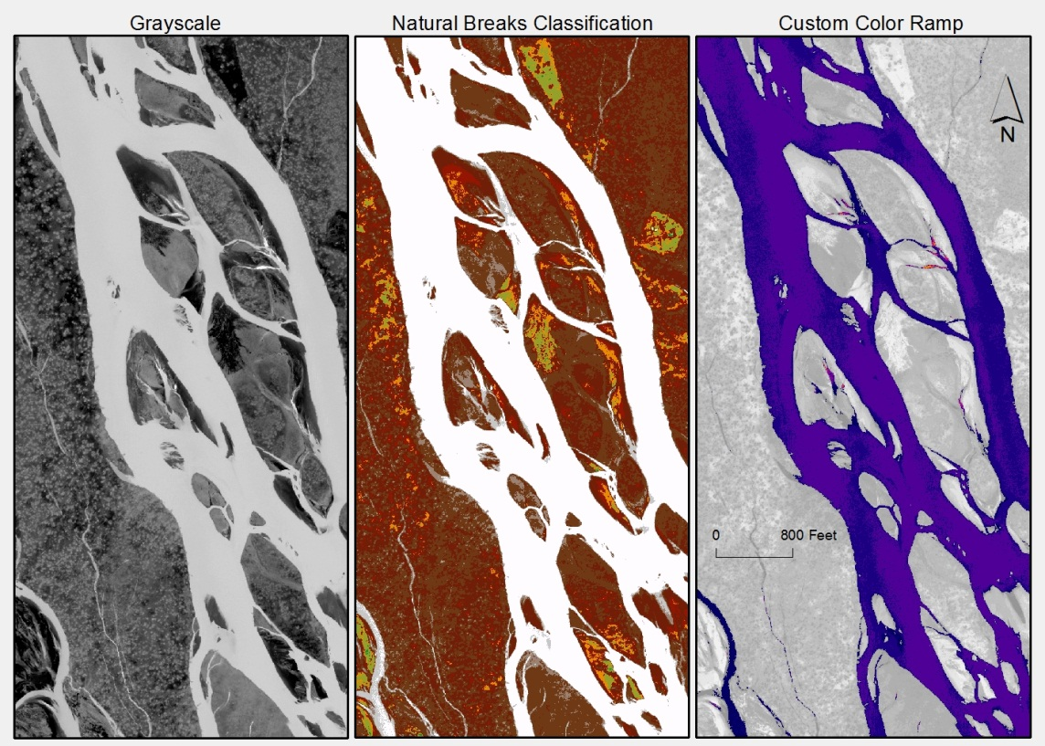
- Examples of different color ramps applied to the same TIR image

Data Processing

Sensor Calibration
The response characteristics of the TIR sensor are measured in a laboratory environment. The response curves relate the raw digital numbers recorded by the sensor to emitted radiance from a black body. The raw TIR images collected during the survey initially contain digital numbers which are then converted to radiance temperatures based on the factory calibration.
The calculated radiant temperatures are adjusted based on the kinetic temperatures recorded at each ground truth location. This adjustment is performed to correct for path length attenuation and the emissivity of natural water. The in-stream data are assessed at the time the image is acquired, with radiant values representing the median of ten points sampled from the image at the data logger location.

Geo-referencing
During the survey, the images are tagged with a GPS position and heading at the time they are acquired. Since the TIR camera is maintained at vertical down-look angles, the geographic coordinates provide a reasonably accurate index to the location of the image scene. However, due to the relatively small footprint of the imagery and independently stabilized mount, image pixels are not individually registered to real world coordinates. The image index is saved as an ESRI point shapefile containing the image name registered to an X and Y position of the sensor and the time of capture.

Geo-rectification
Due to the complexity and width of the river, both manual and automated rectification techniques were used to process the imagery. All imagery was rectified to the high resolution true-color imagery provided by TetraTech. In narrower reaches, individual TIR frames were manually geo-rectified by finding a minimum of six common ground control points (GCPs) between the image frames and imagery available for the area. The images were then warped using a 1st order polynomial transformation and mosaicked into a final image. All TIR imagery collected on October 17 and 18, 2012 was manually rectified.
The wider areas of river flown on October 12 and 13 were rectified using automated techniques due to the multiple flight lines which needed to be tied together. Trajectory and GPS data for the entire flight survey session were incorporated into an External Orientation (EO) file that contains accurate and continuous aircraft positions and heading. Ground control points were created by identifying permanent structures (boulders, high contrast landform shapes, and edges of man-made structures) in the true color orthoimagery that were also easily discernible in the TIR imagery. The coordinates for these points (x,y,z) are recorded from a 10-meter bare earth Digital Elevation Model obtained from the NRCS’s National Elevation Dataset and used to rectify the imagery. The ground control points and EO file are loaded into Leica Photogrammetry Suite which aerial triangulates the thermal images and ties them together. Images are then output into orthorectified mosaics using OrthoVista software. No adjustments were made to cell values so temperature information was preserved.

Interpretation and Sampling
Once calibrated and rectified, the images are integrated into a GIS in which an analyst interprets and samples stream temperatures. The Susitna thermal mosaics were qualitatively inspected for groundwater presence or absence based on water temperatures. A polygon shapefile was digitized to highlight areas of increased groundwater activity. In general terms, the bulk water river temperatures were colder than the emergent groundwater, making subsurface activity easily detectable. Because temperatures exist on a continuum, the polygons should not be used to quantitatively define groundwater flows (increased_groundwater_activity.shp).

Temperature Profiles
In order to provide further thermal interpretation, the median bulk water temperature for the river was sampled at 500 foot intervals and plotted versus river mile to develop a longitudinal temperature profile. The profile illustrates how stream temperatures vary spatially along the stream gradient and highlights any landscape scale trends. The location of named surface water inflows (e.g. tributaries, surface springs, etc.) are included on the plot to illustrate how these inflows influence the mainstem temperature patterns.
The profile was created directly from the TIR image mosaic using the following steps:
- A stream line was digitized and routed based on the final thermal mosaics to best represent the centerline of the channel (susitna_TIR_route.shp).
- A GIS point layer was generated from the routed stream layer at 500-foot intervals and each point was assigned the appropriate river mile measure. Mapped river miles were adjusted to closely match URS in-stream sensor river miles.
- The points were buffered by 25 feet to create polygons within the stream center. Four points which fell on non-water features or were obvious errors do to image mosaic artifacts were discarded.
- The ZonalStatistics feature of ArcGIS was then used to calculate the median radiant temperature and associated statistics contained in each polygon from the TIR image mosaic.
- The median radiant temperatures were then assigned back to the center point and the temperatures were plotted in Microsoft Excel versus river mile (Susitna_TIR_longprofile.xls and sampled_centerline_points.shp).
- A similar process was followed for larger tributaries and sloughs. However, rather than automated spacing of points of points based on the centerline, points were hand placed at the mouth of the tributaries or in wider areas of sloughs and assigned a river mile. Due to the smaller size of the features, tributary and slough points were only buffered by 10 feet for sampling. The tributary analysis was not meant to be comprehensive, but to act as further reference for the longitudinal profile and to highlight significant features (sampled_inflow_points.shp).

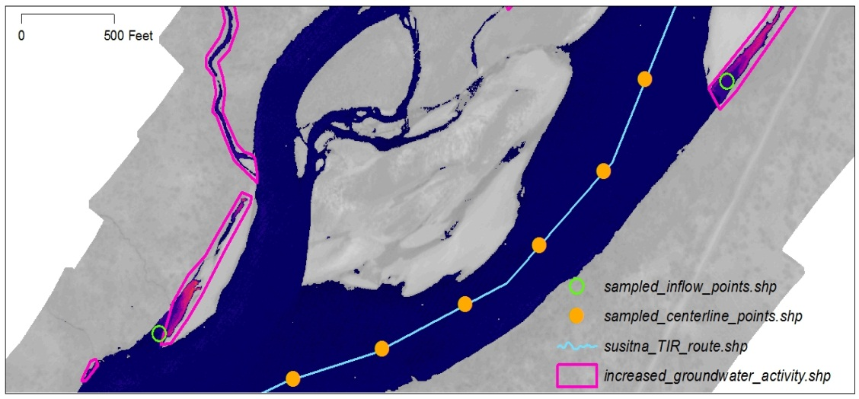
- The image above shows an example of the deliverables provided with the Susitna thermal report

Thermal Accuracy
As mentioned, data from 6 mainstem sensors were used to calibrate the thermal imagery (Figure 3). Table 5 summarizes a comparison between the kinetic temperatures recorded by the in-stream data loggers and the radiant temperatures derived from the TIR images. Due to the multiple flightlines in the lower reaches, the same sensor may be cross-checked across multiple images.
- Comparison of radiant temperatures derived from the TIR images and kinetic temperatures from the in-stream sensors
River  Mile | Sensor ID | Image Frame | Time | In-stream Temp (°C) | Radiant (°C) | Difference
October 12, 2012
103.3 | 103.3_Talkeetna | Susitna1076 | 8:38:59 | 1.26 | 1.3 | -0.01
103.3 | 103.3_Talkeetna | Susitna0957 | 8:34:23 | 1.26 | 1.1 | 0.16
October 13, 2012
126.1 | 1014217_1-_Oct-126.1 | Susitna2705 | 9:41:24 | 0.08 | 0.3 | -0.22
126.1 | 1014217_1-_Oct-126.1 | Susitna2560 | 9:35:06 | 0.08 | 0.3 | -0.22
130.8 | 10174222_1-_Oct-Oct-130.8-LRX35 | Susitna2239 | 9:22:15 | 0.11 | 0.4 | -0.29
130.8 | 10174222_1-_Oct-Oct-130.8-LRX35 | Susitna2822 | 9:45:18 | 0.11 | 0.3 | -0.19
103.8 | 10174222_1-_Oct-Oct-130.8-LRX35 | Susitna0032 | 7:33:16 | 0.10 | 1.0 | -0.90
October 17, 2012
130.8 | 10174222_1-Oct-130.8-LRX35 | Susitna0156 | 8:05:57 | 0.16 | -0.3 | 0.46
136.5 | 10174295_0-Oct_136.5-Susitna Near Gold Creek | Susitna0567 | 8:26:21 | 0.14 | 0.2 | -0.07
138.7 | 10174225-_Oct-138.7-Susitna Above Indian River | Susitna0973 | 8:45:06 | 0.02 | -0.2 | 0.22
140.1 | 1014282_Oct-140.1-LRX 53 | Susitna0950 | 8:44:14 | 0.14 | -0.1 | 0.24
October 18, 2012
Although there were mapped sensor locations above this point, no actual sensor data was available for this date. Calibration focused on matching bulk water temperatures to the prior days’ temperatures. While the relative temperatures of the survey are still considered accurate and highlight groundwater activity, pixel values should not be considered absolute.

The differences between radiant and kinetic temperatures were consistent with other airborne TIR surveys conducted by WSI and within the target accuracy of ±0.5°C; however, there were some discrepancies seen between the in-stream sensors that were not used and the calibrated radiant temperatures of October 17th.
WSI only used sensors that were in the mainstem Susitna and not in areas of potential mixing to evaluate bulk temperatures. Three sensors had data available on Oct 17th but were not used in the accuracy assessment. At mile 140.0, the in-stream sensor recorded a temperature of -3.63°C which was considered suspect. The sensor at river mile 142.0 (Slough 21) was in an area of apparent ground water discharge and therefore reading higher then bulk water temperatures. The sensor downstream of Portage Creek (RM140) was located in an area of mixing which also caused a discrepancy between in-stream and radiant values. The sensor upstream of Portage Creek did not have available data for October.
No in-stream sensor data was available for the imagery flown on October 18th so the calibration focused on matching bulk water temperatures with the calibration on October 17th. Given the conditions at the time of the survey and the lack of sensors to confirm in-stream temperatures, water temperatures in the thermal imagery are below freezing. The calculation of negative temperatures is based on the calibration of the lower sensors and the calculation of parameters to match the October 17th imagery. We opted to retain the areas of negative temperatures in order to maintain consistency in the calibration and the relative temperatures along the stream gradient.
Due to the lack of available in-stream sensor data for the upstream portion of the 17th and full extent of the 18th, temperatures seen in those extents should not considered absolute; however, upwelling activity can still be confirmed due to the contrast between groundwater temperatures and bulk river temperatures.

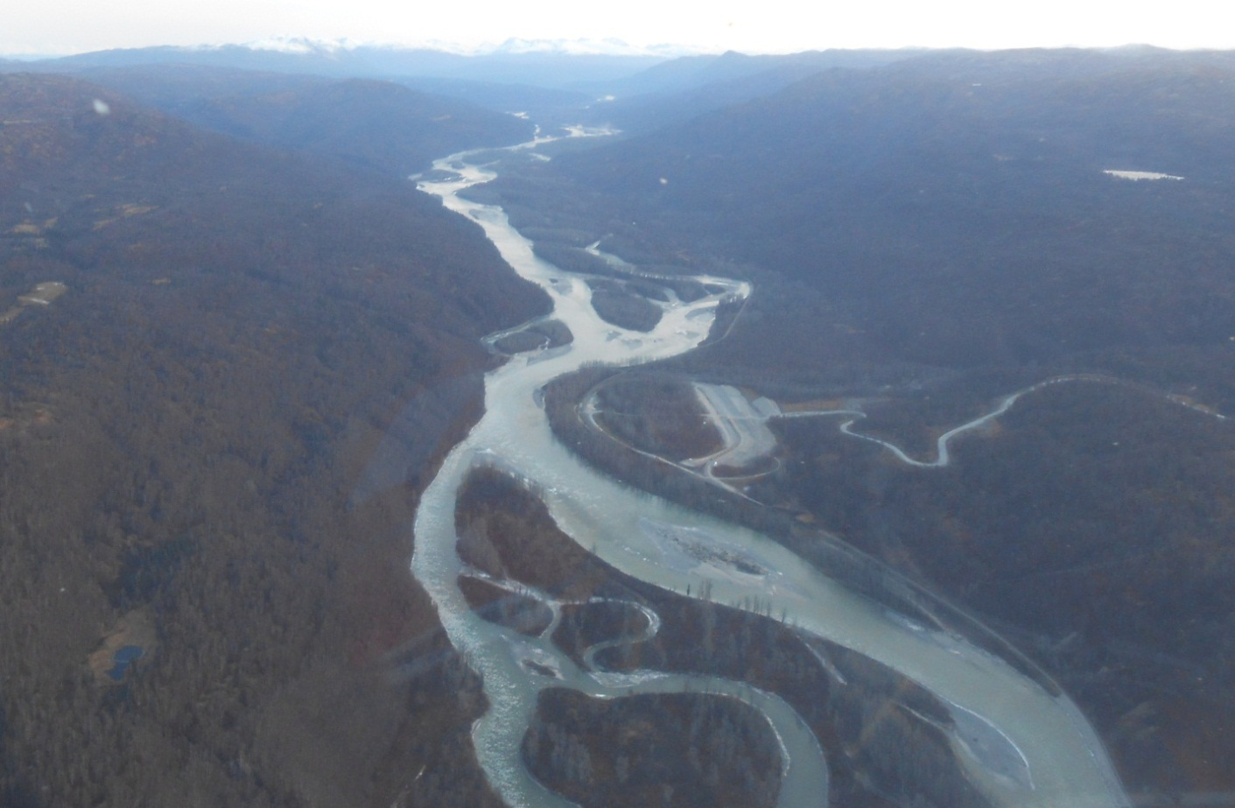

Discussion
Due to the nature of the project, the focus of the survey was to highlight groundwater sources that were warmer than bulk water temperatures on a cold winter morning. The cold air temperatures act to suppress mainstem and terrestrial temperatures and allow the warmer groundwater to stand out in the imagery. Over 500 areas of increased groundwater activity were seen in the thermal imagery from large sloughs to small hyporheic seeps (Figure 6). The bulk of the groundwater activity (>90%) was seen between the Chulitna River and Slough21 (RM 98-143).
Median channel temperatures were also plotted versus river mile for the Susitna River. Significant tributaries and sloughs sampled during the analysis are included on the longitudinal profiles to provide additional context for interpreting spatial temperature patterns (Figure 7). While the groundwater could be easily discerned in the imagery, the longitudinal temperature profile of the mainstem of the river is less informative in this type of winter survey due to the minimal fluctuations in bulk water temperatures. Apparent stream temperature changes of < 0.5°C (0.5 K) are not considered significant unless associated with a surface inflow (e.g. tributary).
The prevalence of groundwater downstream of river mile 140 does appear to impact bulk water temperatures by increasing the overall temperature. The upward slope seen in the profile, particularly between Deadhorse Creek and Lane Creek, is a reflection of this increase in temperatures. Temperatures increase almost 1°C (1.0 K) along this reach.
Though it is not obvious in the longitudinal profile, Lane Creek, Portage Creek @RM117.6, and the Indian River are all contributing significantly warmer water to the mainstem (Figure 8). Ten sloughs of significant size and thermal influence were also noted in the imagery including Slough 8A, Slough 9, and Slough 21.
With air temperatures in the teens on October 18th, parts of the river appeared to be freezing over likely causing the increase in variability seen in the temperature profile on that date. The imagery also reflects the colder temperatures and the ‘colder’ color ramp that was necessary for the upper reaches (Figure 9).
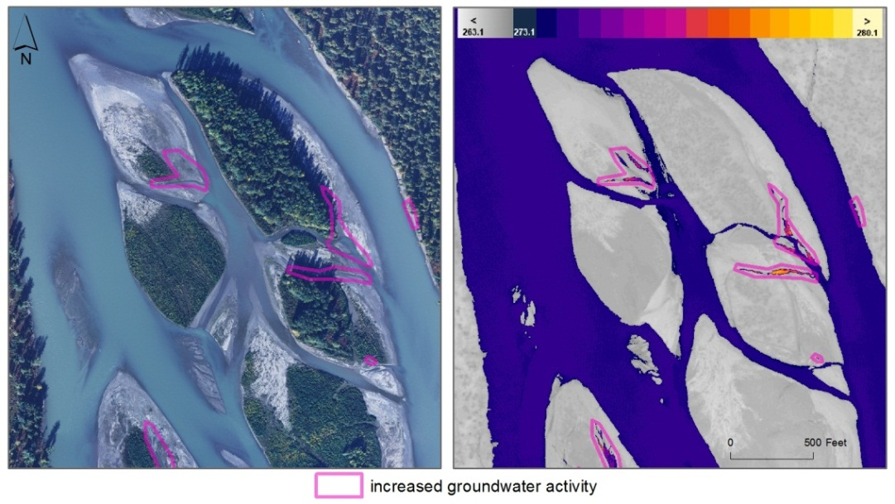
- The TIR/true color image pair above shows an example of the small hyporheic seeps which were detected in the thermal imagery, particularly in the exposed gravel beds.

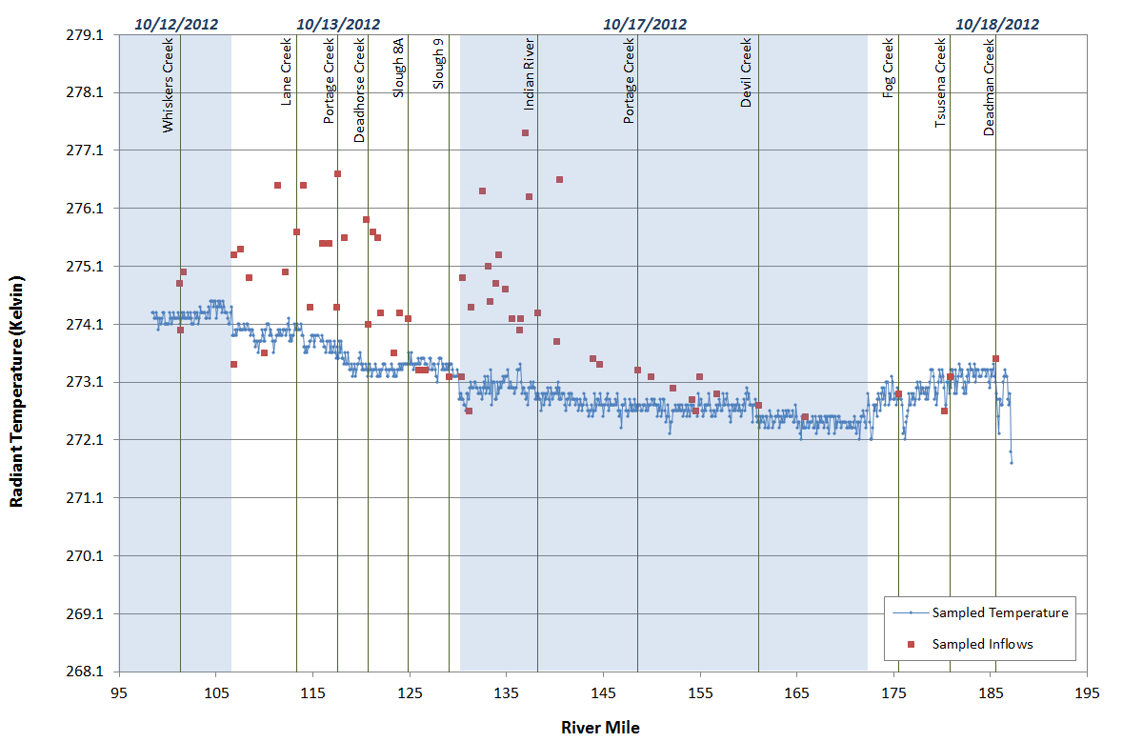
- The figure above shows the longitudinal temperature profile for the Susitna River and sampled inflows. Select named tributaries are shown for reference.

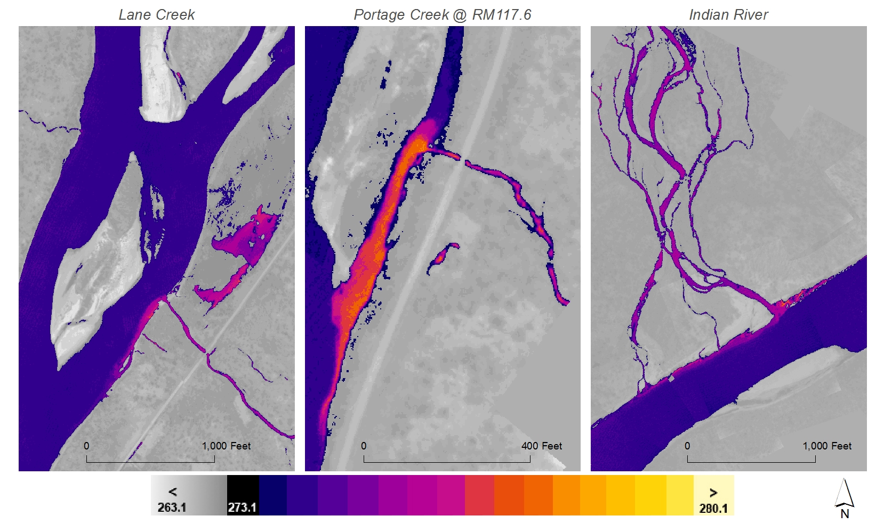
- The TIR images above show three significant tributaries to the Susitna River. While the majority of tributaries were either frozen or at the same temperature as the mainstem, Lane Creek, Portage Creek (lower), and Indian River were all contributing warmer water to the mainstem.
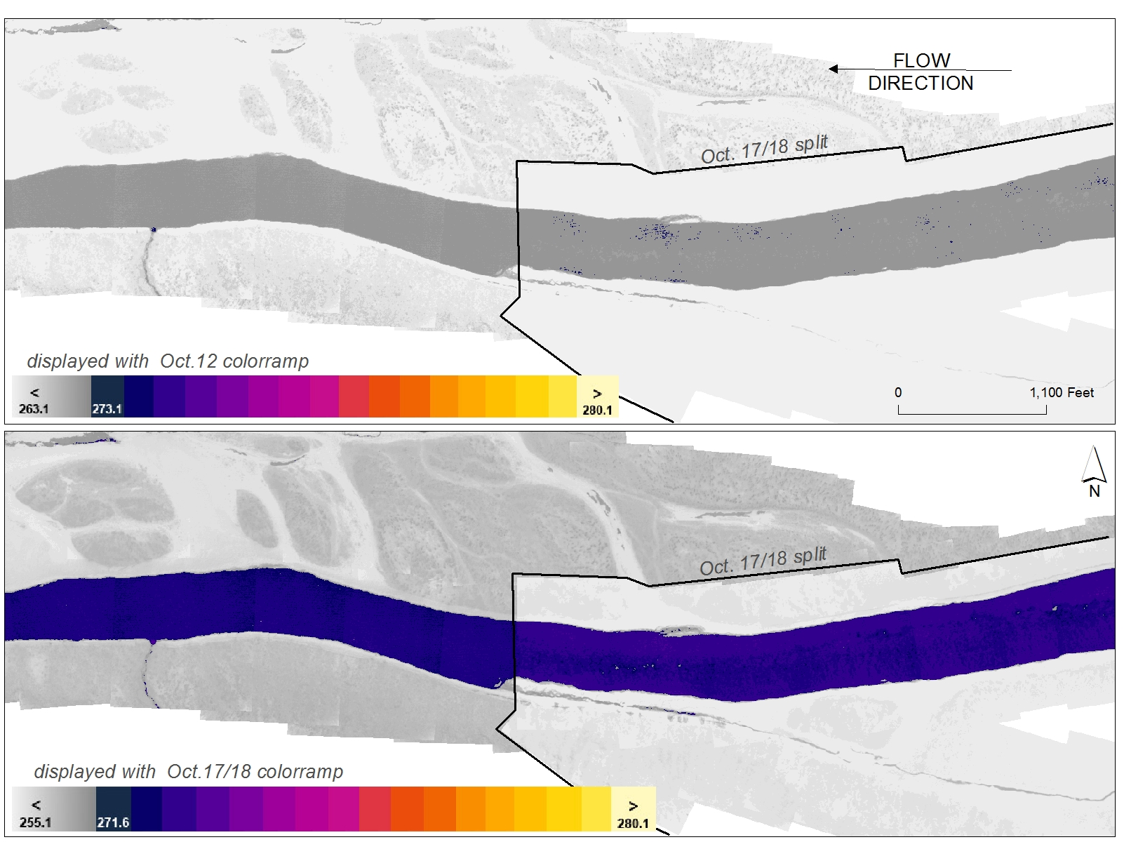
Figure 9. The TIR image pair above shows the junction between acquisition days October 17 and 18. Air temperatures were colder on the 18th, which affects the display of the terrestrial features in the imagery. Bulk water temperatures were significantly colder on the 17th and 18th when compared to the 12th and 13th, requiring a color ramp that displayed water temperatures below freezing.

Summary
Thermal infrared imagery was collected for the Susitna River over a 4-day period in October of 2012. Given the difficult conditions involved in surveying the Susitna and the limited window of weather conditions which will allow for groundwater detection in this type of glacial river, WSI considers the survey highly successful. Hundreds of areas of increased groundwater activity were detected in the imagery, from large sloughs to small hyporheic seeps. Further studies, such as a paired summer survey, would be required to expand on the landscape scale trends seen in the longitudinal profiles.

Deliverables
A list of contracted deliverables provided to URS is shown Table 6.

- Products delivered to URS for the Susitna River
Projection: Alaska State Plane Zone 4 FIPS 5004
Horizontal Datum: NAD83
Units: Feet
Rasters | - Thermal Mosaics (ERDAS Imagine)  - Continuous mosaics of rectified TIR image frames. Layer files included for display by temperature class.  - Cell Values = Kelvin*10
Vectors | - Groundwater Activity (ESRI polygon shapefile)  - Sampled TIR centerline points (ESRI point shapefile)  - Sampled TIR inflow points (ESRI point shapefile)  - Flightline image locations (ESRI point shapefiles)  - Hydrography  - Routed stream centerline based on TIR image mosaics  - NHD stream network (ESRI Geodatabase)
Spreadsheets | - Longitudinal temperature profile (Microsoft Excel)
Analysis | - ArcMap 10.0 project (*.mxd)  - Thermal hydrologic analysis (PDF Report)

Source: Weather Underground. http://www.wunderground.com
Torgersen, C.E., R. Faux, B.A. McIntosh, N. Poage, and D.J. Norton. 2001. Airborne thermal remote sensing for water temperature assessment in rivers and streams. Remote Sensing of Environment 76(3): 386-398.

